
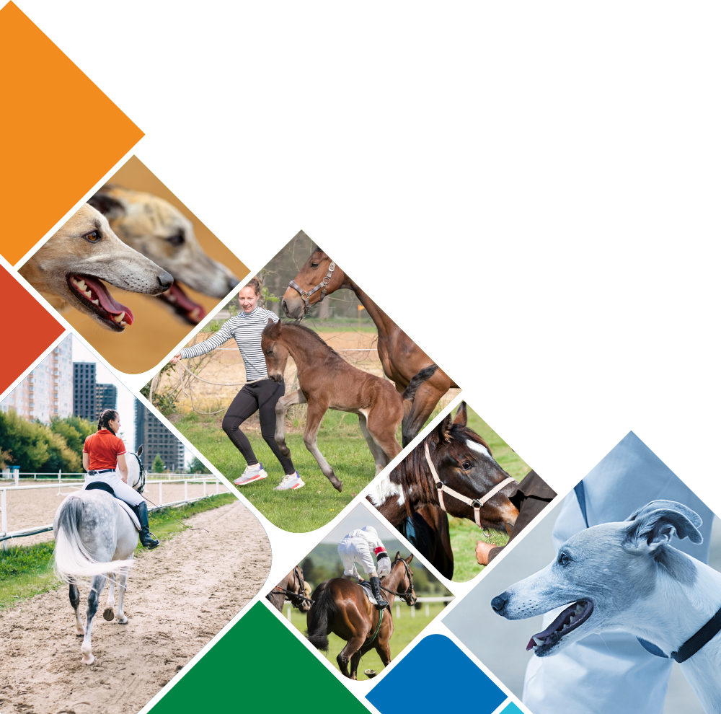

Racing and Breeding

Industry Skills Report

Contents
Acknowledgement of the work of IRCs 3
Acknowledgement of Country 3
Purpose 4
Key Findings and Priorities 5
Industry Reference Committee 6
Method 6
Environmental Analysis 7
Whole of Value Chain Approach 7
Value chain interdependencies 7
Traceability, provenance and blockchain 9
Current crossovers and divisions of the value chain in the VET system 11
Biosecurity, Invasive Species and Pest Control 12
Sustaining animals 13
Complexity of care 13
Animal welfare standards 13
Ecosystem Management and Continuing Climate Adaptation 15
Digital & Automation Practices 16
Safety QA & Regulatory Compliance 17
Workplace and Value Chain Risk Management and Safety Culture 18
Industry Summary and Trends 20
Workforce, Business and Market Summary 20
Training Summary 26
VET training products 26
Rural, Regional & Remote (RRR) Summary 28
Aboriginal & Torres Strait Islander Peoples Summary 29

Acknowledgement of the work of IRCs
We acknowledge the work of the members of Industry Reference Committee (IRC) in the preparation of this report and continuing phases of the project. Their voluntary participation and provision of intelligence and data makes the compilation of this information possible.

This report has been developed from six years of contributions from the Industry Reference Committee.

Acknowledgement of Country
Aboriginal and Torres Strait Islander peoples have a proud and continuous connection to Australia's land and waters. We acknowledge the traditional owners and custodians, and the continuing connection of Aboriginal and Torres Strait Islander peoples to the lands, waters and communities. We pay our respects to Elders and Leaders, past and present, and to all Aboriginal and Torres Strait Islander peoples who have supported our work.

We acknowledge the importance of learning from Aboriginal and Torres Strait Islander peoples’ unique history of land and ecosystem management, art, culture and society. Their connections are particularly important given our involvement in work directly connected to utilisation, care and stewardship of Australia's land, waters and ecosystems, and the animals, trees and plants that thrive across Australia.

The Industry Reference Committees and Skills Impact have been working to develop improved participation of Aboriginal and Torres Strait Islander enterprises, businesses, communities and people in our work. We will continue to work to develop strong, mutually beneficial relationships with Aboriginal and Torres Strait Islander partners who can help us deliver better outcomes for Aboriginal and Torres Strait Islander peoples, recognising their expertise in improving quality of life, employment opportunities and skills outcomes in their communities and for the whole of Australia.

Purpose
Skills Impact has prepared this Industry Skills Report at the request of the Racing and Breeding Industry Reference Committee (IRC). It provides in-depth information about industry-specific skills and issues covered in the Agribusiness, Food and Fibre Industries Skills Report.

As one of eight industry-specific Skills Reports with matching structures, this document is designed to assist collaboration across industries and the streamlining and reform of the Australian skills and VET system. This may aid the implementation of the Skills Minister’s Priorities by supporting:
- Greater labour mobility through stronger recognition of cross-sector and transferable skills
- Better use of industry and educator expertise to ensure better quality outcomes
- Improved pathways advice to support lifelong learning and build peoples’ labour market resilience
- Australia’s capacity to grow, compete and thrive in the global economy, especially in context of the concurrent impacts of COVID-19, automation and digital transformation on the skills required for jobs now and into the future.
The IRC requested that this report be prepared to support improvements in the skills system, including work on:
- Industry workforce planning and strategies to address workforce shortages
- Documenting shared standards and regulations across industries to support end-to-end systems planning and avoid duplication
- The provision of evidence, data and intelligence to add value for industries beyond a narrow focus on training package development, and to inform future Industry Clusters or similar bodies approved to undertake work within the Australian skills and VET system
- Creating foundations for potential qualification reforms with a greater emphasis on skills families and portable skills
- Identifying shared ‘skills domains’ to aid in simplifying and streamlining national VET qualifications across industry groupings.

Key Findings and Priorities
The Racing and Breeding (RGR) industries have experienced less disruption than many other industries over the last two years due to high-level biosecurity and health protocols allowing continuation of the industry in most jurisdictions. However, the industry did not come out unscathed, and the Tasmanian industry in particular is still recovering. While career opportunities are available, there are issues attracting labour.

The addition of the occupation of track rider to the ANZSCO Codes has been warmly greeted by the industry, opening avenues to address a major skills shortage.

The updated RGR Training Package has been working well and there were indications that RTOs were considering placing qualifications on scope until the onset of COVID-19 and the rationalisation of operations for many RTOs. Even in this environment, new breeding offerings have commenced in NSW.

A number of integrity (Stewards) bodies have been looking at ways to facilitate training and skills gaps. Skills Impact has been communicating with bodies to ensure the RGR Training Package remains relevant and that consideration is being given to skilling opportunities across jurisdictions and sectors.

The IRC considers that attracting new entrants remains the biggest challenge for the industry and many efforts are being taken to this end. The IRC suggests that the priorities of for consideration by the new industry cluster body (assuming establishment proceeds), should include any support that can be given to these endeavours, including:
- Creating nationally consistent assessment and training resources across all qualifications, with immediate priorities for track riders and stewards/integrity qualifications
- Activities to support engagement with employers that have identified RTO barriers to delivery
- Mapping of career pathways to assist the National Careers Institute to address critical workforce shortages through the promotion of careers
- Review of RGR40221 - Certificate IV in Racing (Jockey) to remove prerequisites and duplications, included in the core concerning riding, to free up training hours to include updated skills required to fill training gaps.
- Identifying digital skills needs utilising the Digital Workforce Capability and VET framework currently in development (along with other digital capability frameworks)

Signed on behalf of the Racing and Breeding Industry Reference Committee:

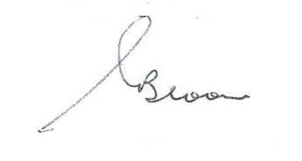

Chair: Geoff Bloom
Date: 26/09/2022

Industry Reference Committee
The Racing and Breeding IRC (RGR IRC) is responsible for national training package qualifications relevant to racing and breeding in the thoroughbred, harness and greyhound industries.

Qualifications overseen by the IRC are in the RGR Racing and Breeding Training Package.

The RGR IRC is supported by the Skills Service Organisation, Skills Impact.

Name | Organisation or Area of Expertise
Geoff Bloom (Chair) | Racing Australia
Ron Fleming (Deputy Chair) | Racing and Wagering WA (RWWA)
Vacant | Expertise in animal welfare and breeding
Briony Moore | Racing SA
Cameron Wright | Australian Workers Union NSW
Cecelia Huynh | Greyhound Racing NSW
Vacant | Greyhounds Australasia
Dr Ruth Taylor | Expertise in animal welfare and breeding
John Sutherland | Expertise in animal welfare and breeding
Kathleen Mullan | Harness Racing Australia
Kevin Ring | Australian Jockeys Association
Lisa Hocking | Racing Victoria
Jill Geiblinger | Racing Queensland
Ruth Taylor | Expertise in animal welfare and breeding
Shaun Snudden | Harness Racing NSW
Stuart Rich | Racing NSW
Wayne Lee | Australian Trainers Association

Method
Industry Reference Committees oversee the work of Skills Service organisations in the collection and analysis of industry intelligence, which is used to:
- Identify industry skills needs and challenges
- Identify issues and potential improvements to the Skills and VET system
- Provide the basis for work to update VET training package products
- Provide an information source for industry to assist with business, workforce, skills and training planning.
The information in this report has been collated from a variety of sources identified by Industry Reference Committee members and industry stakeholders who have participated in consultations with Skills impact. It also utilises data and information from official sources and major commercial providers through the assistance of the Australian Government Department of Education, Skills and Employment.

Environmental Analysis

Whole of Value Chain Approach
The diversity of racing and breeding industry participants and arrangements creates a unique operating environment. This industry requires animal and human participants to be trained to a high level to ensure the safety and wellbeing of both.

The value chain entails a great deal of mutual dependence across value chain operations, which is further impacted by external factors, such as household discretionary income and public perceptions of animal welfare, which shape racing event attendance and gambling expenditure, and by trends in the buying and selling industries that form partnerships with racing and breeding businesses, including from agriculture and sport and recreation. Such trends are increasing pressure on racing industries to maintain a transparent approach to all operations.

Value chain interdependencies
The Racing and Breeding (RGR) value chain encompasses all stakeholders who are often linked in cooperative and collaborative relationships to provide consumers with products, services and entertainment. These include up- and down-stream suppliers, animal ethicists, animal feed processors, horse farmers (including stud hands, stud grooms, stud managers, broodmare managers, stallion managers, and foaling attendants), greyhound breeders, farriers, equine dental practitioners, animal rehoming and adoption services, veterinary services, animal therapy providers, animal insurance services, float drivers and other transport services, animal behaviourists, racing equipment manufacturers, stablehands, kennelhands, trackriders, handlers and trainers, jockeys, promoters, agents, betting agencies, principle racing authority staff, racetrack maintenance staff, facilities managers, and inspectors and regulatory officers.

Greyhound racing, for example, supports, and is supported by, a large value chain network in which multiple industry sectors and jobs are interdependent (see Figure 1). The greyhound racing industry is an important customer for many suppliers of goods and services. This includes suppliers of both raw materials and ones that are specifically developed for the sport. Similarly, the industry both directly and indirectly sustains employment in other industries; for instance, retail, tourism, accommodation, transport, and advertising, especially in regional areas.
Figure 1: Value Chain of Greyhound Racing in Victoria
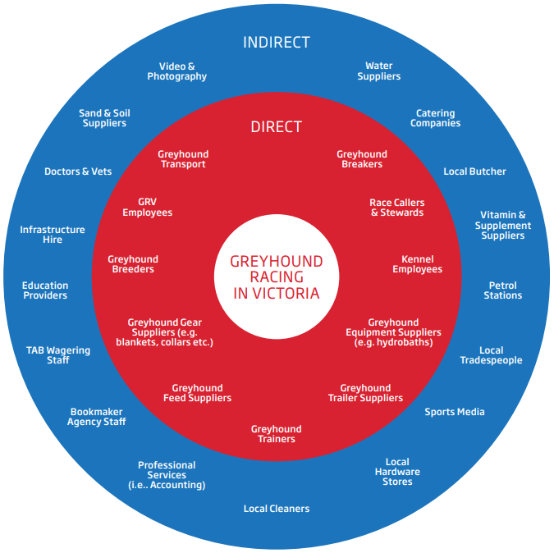
Source: IER (2017); Size and Scope of the Victorian Greyhound Racing Industry
Horse breeding operations provide agistment services and breed horses for functions in multiple industries, including for racing (thoroughbred and standardbred), equestrian (dressage, eventing, cross-country and show jumping), cutting (working with cattle), pony club, dressage, rodeo, western disciplines, campdrafting, stock work, endurance and polo. The industry also breeds miniature horses, Arabs, Welsh Ponies, warmbloods, stock horses, and quarter horses for different purposes.

Horse and greyhound racing industry participants generate revenue in various ways according to the functions they fulfill; for example, race clubs generate revenue from membership fees, media broadcast rights, event ticket sales, and food and beverage services. Trends in betting expenditure and type have a strong effect on industry revenue because race clubs receive a portion of wagering turnover (often from on-track agencies and racing authorities), and state racing authorities generate most of their revenue through agreements with betting agencies over a share of wagering margins.

Extensive inter-sectoral services and income generation also add to the complexity of market arrangements, with operators often contracting services to other industry participants; for example, racehorse owners pay trainers to prepare their animals for competitive racing, and jockeys/drivers to ride/drive the horses, with revenue generated through winning prize money, which is distributed by race clubs (that act both as industry operators and key major markets).

When their racing careers finish, some racehorses and greyhounds are purchased by animal breeders from their owners for breeding purposes to sire future contestants (though in harness racing many owners breed their racehorses themselves). The owners of retiring animals not being purchased for breeding have obligations to ensure their post-racing care, which entails working with verified resourcing programs. Greyhound owners, for example, are working with the Greyhound Adoption Program (GAP) to determine rehoming options, modify greyhound lifestyle and environment, and prepare and lodge required documentation. Across this value chain are responsibilities for greyhound owners and trainers, greyhound health workers, and Greyhound Adoption Program supervisors and assistants, who all collaborate to ensure greyhounds – and their new owners – receive education to transition greyhounds bred for racing to become pets in new homes.
Figure 2: RGR value chain
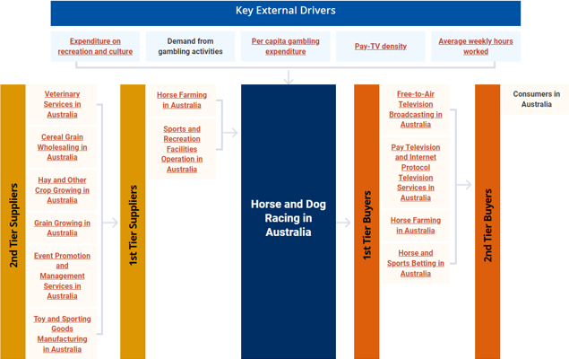
Source: IBISWorld (2022); Horse and Dog Racing in Australia

Traceability, provenance and blockchain
Traceability is the function of tracking the movement of animals, from their origins and across all stages of life. This is associated with participant and consumer demand for transparent information on animal breeding and welfare to meet sporting requirements and cultural expectations.

Traceability systems track how an animal has been bred, sold, broken-in, trained, transported and, eventually, retired. This includes recording compliance with regulatory requirements, animal and worker safety, prescribed handling practices, and chain of custody compliance. Traceability reduces the potential risk of fraud and provides evidence to support claims of ethical and welfare-observing practices.

Microchipping is an established form of traceability used for greyhounds. For example, the Greyhound Microchip Registry, licenced under the Domestic Animals Act 1994, is operated by Greyhound Racing Victoria (GRV). All greyhounds born in Victoria are microchipped and registered on the registry, including both racing greyhounds in the care of participants registered with GRV, and retired greyhounds that have been re-homed. Microchipping will soon be the sole form of traceability for standardbred horses in Australia after freezebranding is phased out.

At present, property owners and horse carers in most jurisdictions must have a Property Identification Code (PIC) for the land on which horses reside. Each PIC usually includes details of the property owner/manager and relevant information on the land comprising the property (including resident species and geospatial information). The PIC system then acts as a tool to record the arrival and departure of horses, which enables contact tracing. Such traceability protocols are supplemented by more advanced systems to support integrity and performance recording by racing participants such as Racing Australia, Harness Racing Australia and Greyhounds Australasia.

The design and introduction of a new national traceability system, with a biosecurity focus for horses, donkeys and mules in Australia, is being advanced by the National Horse Traceability Working Group (NHTWG). The purpose of this system is to address the potentially significant market, animal and human health impacts of horses being vectors in the spread of diseases, such as Equine Influenza, Vesicular Stomatitis and Hendra. A traceability system would help horses of interest be located quickly and reliably managed in the event of an emergency disease outbreak. This would assist authorities in promptly enacting preventative procedures to contain and shorten the impact of the disease.

The NHTWG will provide Agriculture Ministers with recommendations regarding the implementation of a National Horse Traceability System (NHTS) prior to a scheduled meeting in 2022. These recommendations will review current horse tracing efforts and data collection and address the design, introduction, operation, legal framework and enforcement of a new traceability system, especially associated with biosecurity, welfare and broader horse industry and stakeholder requirements. This will likely include advice over
- the standardised use of implanted microchips (transponders) to permanently identify animals
- continuing use of industry-managed databases that register horses (including descriptions, brands, markings, and microchip numbers) and their owners
- published protocols for compliance monitoring, enforcement, evaluation, and periodic review
- ongoing education program for horse industry participants to understand their responsibilities.
The NHTWG will communicate the obligations of industry participants over property registration, movement records, microchip application, and associated data management. This will require industry participants to upskill for the use of all mandatory recordkeeping procedures. These stakeholders include horse owners and carers, transporters, selling agents (including operators in saleyards, public auctions and online selling platforms), processors (including abattoirs and knackeries), racing authorities, event organisers, and studs.

Current crossovers and divisions of the value chain in the VET system
The protection and support of the whole value chain and the social licence need to operate is very dependent on the animal care and management industries, as well as the sport, entertainment and service industries.

Acknowledging the inter-connections and interdependencies is becoming increasingly important because of the impact that issues in one area can have on other areas, or even across all areas of the value chain.

The importance of identifying and monitoring systems that cross over the value chain has been highlighted by recent concerns over social activism incidents that have disrupted racing activities and food contamination (for example, toxic horse meat being traced in pet food). These events require prompt actions be taken and a clear understanding of which links in the value chain are affected.

In the Australian skills and VET context, distinguishing affected parts of the value chain helps to identify priority work on cross-sector projects or where relationships need to be established with oversight bodies to ensure their appropriate involvement in skills and VET development. It also facilitates the identification of transferable skills (and skills gaps) for people working between industries, and who may seek future employment in different occupations and sectors.

Please see the Agribusiness, Food and Fibre Industries Skills Report for accounts of the various overlaps between the animal care and management industry and the other industries covered by that report. Further connections include:

Sport, Fitness and Recreation
The Racing industries are directly associated with sport, fitness and recreation, which currently sit within the Sport, Fitness and Recreation (SIS) Training Package. The SIS Training Package comprises four broad areas: sport, fitness, outdoor recreation and community recreation. A significant proportion of the activities in these areas involve animals, requiring skills in their management, handling, exercise, wellbeing and care, training, coaching, administration and facilities.

Tourism and Hospitality
The tourism and hospitality industries currently sit within the Tourism, Travel and Hospitality (SIT) Training Package. The SIT Training Package comprises four broad areas: tourism, hospitality, events and travel. All of these are very strongly connected with racing and breeding, with racing events often being central to the economies of rural and remote communities based on the associated tourism, hospitality, events and travel activities. Major metropolitan racing carnivals and events include some of the largest international events contributing to the Australian economy. A significant proportion of the tourism industry involves animal-related recreation and wildlife activities.

Transport and Logistics
Racing and Breeding are national industries requiring the movement of animals and staff around Australia, and internationally. There are special requirements for the transport

Other connections with VET training packages
The racing and breeding industry also intersects with industries that utilise or encounter animals as part of their work, or which provide transferable skills relevant to roles in animal care and management. This includes industries supported by the following training packages:
- ACM – Animal Care and Management
- AHC – Agriculture, Horticulture and Conservation and Land Management
- BSB – Business Services
- HLT – Health
- MSM – Manufacturing
- PSP – Public Sector
- PUA – Public Safety
- SIR – Retail Services
- SIS – Sport, Fitness and Recreation
- TAE – Training and Education

Biosecurity, Invasive Species and Pest Control
Biosecurity systems are now recognised as a primary factor in preserving human and animal health, regionally, nationally and internationally. The racing and breeding industry has strict biosecurity protocols, which were first developed because of ongoing health issues, such as strangles and stable viruses, and strengthened following national outbreak events, such as equine influenza in 2007-2008. For this reason, the industry was able to continue operating in the COVID-19 environment with fewer disruptions compared with many other Australian industries.

Despite this effectiveness, it must be noted that some racing and breeding activities were curtailed, especially in regional, rural and remote areas. In 2020, all three codes – horseracing, harness racing and greyhounds – ceased operating in Tasmania for a period, which left participants struggling to continue operations, especially with the prevailing trend of lowering race day attendances. Meanwhile, the breeding and sales season, which is economically crucial for many regional communities, was similarly disrupted across Australia, with lucrative thoroughbred auctions being held exclusively online, leading to many horses being withdrawn from catalogues.

Protecting the health and welfare of horses from biosecurity risks and disease is imperative for the racing industry, as incursions are extremely costly both to the economic and emotional health of participants. In May 2022, the Australian Government Department of Agriculture, Water and the Environment hosted a webinar on three emerging biosecurity risks for Australian horses: Japanese encephalitis virus (JEV), Hendra virus variant (HeVg2) and African horse sickness virus (AHSV).

Such challenges highlight the need for biosecurity skills and training to support the continuation of industry operations, which are so important to the economy of many regional, rural and remote communities. This includes training for the biosecurity systems associated with the forthcoming National Horse Traceability System, breeding farm biosecurity plans, protocols for animals being moved across state and international borders, vaccination programs, and research, development and public information programs.

Sustaining animals
The sustainability of the horses and greyhounds, both as individual animals and in terms of stock control to ensure there is no over-breeding, is critical to the social licence under which the industry operates.

Complexity of care
Looking after animals, like caring for humans, is fundamentally different from tending to machinery, equipment and infrastructure, and requires skills that take into account the biological complexities and behavioural variability that animals demonstrate.

As elite athletes, racehorses and greyhounds require:
- ongoing fitness conditioning and training, with routines tailored to both animal and environmental variables
- a balanced, nutritious diet
- access to clean water
- a spacious living environment that allows free movement and behaviour, while providing shade, shelter and secure housing
- behavioural development opportunities, including positive, safe, species-appropriate experiences and social interactions with other animals and people.
- health monitoring and therapeutic interventions as appropriate, including from farriers, dental technicians, massage therapists, veterinarians, and groomers.
As well as physical care, the environments on which racing animals are homed must maintain certain standards; for example, the pastures where horses live need to be rested so that grass can rejuvenate for future grazing that meets their nutritional needs (in addition to weed removal). This requires farmers to enact rotational grazing plans, which require skills and knowledge in areas such as sustaining soil health for effective grass fertility.

The breeding and racing industries need also to mitigate risks associated with potential overbreeding and wastage. In recent years, racing authorities in each state have worked to drastically improve rules and regulations associated with animal welfare and ongoing care. Based on strong industry support, improved animal welfare skills and knowledge criteria have been included in the updates to the RGR Training Package. Specifically, training package products have been developed for re-educating and re-homing retired racing horses and greyhounds.

Animal welfare standards

Framework for Thoroughbred Welfare
In January 2020, groups from racing and breeding began collaboration on a national review to ensure implementation of an industry framework for the welfare of thoroughbreds throughout different stages of their life. An independent panel, the Thoroughbred Aftercare Welfare Working Group (TAWWG), was established to conduct the inquiry and released A Framework for Thoroughbred Welfare in 2021. Key information sharing and deliverables were set out in each section:
- National and industry standards
- Welfare regulation and policy
- Traceability and data
- Sustainable racing and aftercare
- Re-training and rehoming
- End-of-life responsibilities
- Research, education and communication
There were 46 recommendations made across these sections, including that, with the support of industry, governments should develop national welfare standards for all horses. These do not currently exist for horses as they do for other species, such as cattle and sheep. This would mandate minimum care for horses at all stages of life, including for thoroughbreds after they exit racing and breeding.

There were also calls for increased skills and formal training:

‘Many workers in the industry play a key role in horse development and behaviour. Often many have had little formal training. Improving the skills of the workforce will improve welfare outcomes. […] There are benefits of learning skills and building knowledge while in the workforce, but there is an increasing awareness in the industry of the needs and benefits of more formal training and education.’
Thoroughbred Welfare Initiative (2021); The most important participant: A Framework for Thoroughbred Welfare; pp.117 and 120.

However, the report also notes the lack of registered training organisations (RTOs) willing or able to deliver relevant qualifications and training.

Animal Welfare in Harness Racing
Each state or territory has set out welfare guidelines for standardbred horses in harness racing. Harness Racing Victoria (HRV), for example, has developed an Animal Welfare Framework which outlines its strategy and expectations for the care of standardbred horses. This framework also includes Welfare Guidelines for Trainers, Raceday heat policy and Raceday Veterinary which will assist trainers and industry participants. Animal welfare is central to the future of the Victorian harness racing industry and is a guiding principle in the strategic direction of the organisation. Any breaches of the animal welfare standards, as set out in the framework, are to be referred to the HRV Integrity Department for investigation.

HRV recognises that the treatment of injuries and other specialist care required for horses is expensive, so in the interests of maintaining a high standard of welfare for all standardbreds racing in Victoria a Specialist Veterinary Referral subsidy was introduced. Further activities and programs include:
- an online horse welfare training module for industry participants, which is mandatory for all licensed persons to complete as part of HRV’s annual licensing process
- increased resources for animal welfare functions and investigations through the appointment of an animal welfare Investigative Steward
- promotion of a retraining program, HRV HERO, which has recently been reviewed and resulted in an increase of re-trainers, which reduced the waiting time for a retired standardbred horse to enter the program.

Animal Welfare in Greyhound Racing
Greyhounds Australia is continuing the implementation of a welfare strategy for all greyhound racing in Australia and New Zealand. The strategy has specific actions which have been and are continuing to be implemented, including:
- The introduction of mandatory micro-chipping that improves industry integrity, and facilitates more accurate tracking of individual greyhounds throughout their lifecycle;
- The strengthening of Greyhound Racing Rules to ensure owners are required to notify their Controlling Body when a greyhound has been retired from racing;
- The establishment of a dedicated GA Welfare committee which is tasked with the development, implementation and monitoring of national welfare initiatives and setting of industry benchmarks;
- The introduction of export guidelines that ensures Australasian greyhounds can only be exported to countries that have a standard of care and accountability comparable to that here in Australia;
- Reducing injury risks for racing greyhounds by prioritising capital works at racetracks;
- Increasing the number of kennel inspections and penalising participants for non-compliance; and
- The development in each state of a dedicated and industry resourced re-homing program for greyhounds that are no longer suited to racing.

Land Transport of Horses
The Australian Animal Welfare Standards and Guidelines - Land Transport of Livestock were published in 2012 and explain best practice for operators involved in livestock transport. However, scientific knowledge, industry practices and community expectations have evolved since 2012 and, in 2020, an independent inquiry into the management of retired racehorses (‘the Martin Inquiry’) identified problems with the way horses were being transported and that a national approach was required to rectify the issues. The Animal Welfare Task Group was tasked to carry out a review of the standards and guidelines, and agreed to consult on proposals specific to horses, including over requirements to provide water and rest during the journey, prevent heat stress, ensure horses are fit for the intended journey, set the minimum age for foals to be transported, and over the use of restraints.

Ecosystem Management and Continuing Climate Adaptation
Please see the Agribusiness, Food and Fibre Industries Skills Report for more information about managing the protection, sustainability and health of Australia's ecosystem.

The racing and breeding industries require the knowledge and skills to the manage the protection and health of racing animals, which includes considerations of the climate and lands on which they live and race. Many factors can affect racing track conditions on a daily basis, including soil composition, track watering and grading, and the weather, whether associated with gradual warming or extreme events such as floods (see Natural disaster planning, response and recovery below).

Greyhounds and horses can suffer from the effects of climate change, requiring that owners and managers are able to recognise and respond to sub-optimal conditions that impact on animals, including:
- Heat: climate change is exposing thoroughbred racehorses to heat stress even outside of the months summer. This may require adaptations such as providing more fresh water and shade (e.g. planting more trees in paddocks), and more frequent coat maintenance
- Air quality: smoke from the 2019-2020 bushfires had a profound effect on some racing activities
- Drought: water shortages in heat-affected areas can turn fields dry, with excessive dust that can cause breathing problems. This requires turf management strategies, such as using drought-resistant varieties
- Pests: biting insect populations can increase during long, moist summers. Steps to mitigate insect populations may be necessary (with sustainable spraying methods), as well as drainage control measures to avoid standing water where insects breed. Animals may also require vaccinations to protect against disease transmission.

Digital & Automation Practices
Digital evolution in the breeding industry is associated with information technology and breeding programs to produce specific characteristics in horses, such as athletic physiology. Technological advancements, such as remote sensing, are further being applied in horse farming to support the effective and efficient raising of farm horses.

Artificial intelligence (AI) technology provides opportunities for thoroughbred horse farmers to monitor, collect and analyse large pools of data on their animals as well as external variables such as weather and humidity. According to IBISWorld, AI and data analysis technology is likely to become an increasingly important part of thoroughbred horse farming operations over the next five years.

Technology used in the racing industry includes digital registration and identification of individual greyhounds and horses, as with Traceability, provenance and blockchain systems discussed above. Diagnostic and healing technologies are being used to treat injuries and monitor overall health. Skeletal issues and lameness can be effectively identified using equine MRI machines and X-ray machines. 3D printing has been used to create splints and casts for injured horses, as well as printing race horseshoes, which are lighter and can be designed to fit the horse perfectly based on scans of its hoof. The use of robotics is also being explored through innovations such as lift systems that take the place of traditional slings when moving horses during recovery from conditions such as laminitis and broken legs.

Sport science technologies are emerging in racehorse training. To capture data on physical variables and performance, smart saddles have been used to monitor a horse’s individual movements. These saddles have a microchip inserted so that the stride and symmetry of a horse’s gait can be measured, thus allowing trainers to create personalised programs based on their attributes. Other training technologies include artificial surface gallops and a sea walker (a pool of chilled salt water that allows horses to walk off injuries and strengthen their muscular development) at Godolphin Racing stables.

Digital technologies are also likely to be increasingly used to improve jockey safety. In recognition that concussions and stress increase decision-making that exacerbates the risk of falling, research by AgriFutures has ‘aimed to determine whether a novel virtual-reality concussion tool, CONVIRT, which was built specifically to test jockey concussion, could provide evidence that better informs return-to-ride decisions’. Such technologies and tools are still emerging, but are likely to receive wider attention in light of the challenges of maintaining Error: Reference source not found (as discussed below).

As digital methods for improving training, health and safety improve across the racing and breeding industries, there is likely to be greater demand for formal skills and training delivery, which, at present, is limited by the lack of RTOs able to offer relevant courses.

Safety QA & Regulatory Compliance
The racing and breeding industries are characterised by a high level of regulation. Strict regulations govern thoroughbred breeding and the recording of bloodlines, because this dictates the value of foals. For identification, all foals are microchipped and issued with ID cards, which contain information on bloodlines, gender, markings and the breeder. This information is kept by the Australian Stud Book for thoroughbreds and Australian Harness Racing for standardbred horses.

Artificial insemination of thoroughbred racing stock is strictly forbidden. Industry stakeholders note that, without this regulation, the value of breeding animals would decrease and the number of thoroughbred horses would increase, which would drastically impact the viability of breeding businesses and lead to oversupply issues.

Under current biosecurity regulations to limit the spread of diseases such as equine influenza, live horse imports (except from New Zealand) are required to go through 21 days of pre-export quarantine before departing for Australia, and a further 14 days once they have arrived. The industry is also subject to heavy regulation regarding environmental issues, such as effluent disposal.

The Australian Rules of Racing can only be altered by the Australian Racing Board. These rules define common practices, conditions and integrity standards for racing in Australia. So long as they are consistent with the Australian Racing Board's rules, individual state and territory racing administrations can also establish and enforce local rules for specific issues.

The Australian Rules of Harness Racing can only be altered by Harness Racing Australia (HRA). HRA is the forum and co-ordination point between the State Controlling Bodies for uniformity of rules.

Licensing criteria for owners and trainers are that they have a good civil record, the capabilities and resources to train thoroughbred horses, appropriate stabling and training facilities, and will adhere to the Australian Rules of Racing.

At all levels, greyhound racing in each state and territory is tightly controlled by Greyhound Racing Boards with wide legislative powers. These statutory authorities register all industry participants, including attendants, trainers and owners, as well as licensing all greyhound names, clubs and tracks. Local council regulations can determine peoples’ part-time involvement in the industry, with most councils in built-up areas only allowing up to two greyhounds per property, while this number can be greater in rural areas depending on local council policy

Workplace and Value Chain Risk Management and Safety Culture
Safety challenges in the racing and breeding industry relate to the actions and wellbeing of both humans and animals. These are ongoing challenges and concern both new and experienced participants. SafeWork Australia published a guide to managing risks when new and inexperienced persons interact with horses, which are supplemented by requirements in different jurisdictions.

A jockey is five times more likely to suffer a concussion than an AFL footballer and is reputedly the second most dangerous job in the world. AgriFutures describe how ‘injuries among licensed jockeys in the years 2002-2010 led to claims that cost $9 million per year, with the mean cost of a race day fall $33,756. If the fall involved a head injury, the mean cost was $127,127’.

Industry is seeking to improve the safety of jockeys and the welfare of horses in various ways, including the AgriFutures project to better identify concussion in jockeys and National Horse Traceability Register. A review team in the National Jockey Safety Review has made recommendations for each State Principal Racing Authority to implement, including:
- An overhaul of apprentice training and employment conditions to improve safety
- The development of competencies and assessment materials to ensure suitable training and assessment of all trackriders
- New standards for jockey protection and comfort, including for vests and helmets
- Changes to minimum riding weights and the adoption of suitable minimum topweights
- Standardised treatment of careless riding infringements to discourage repeat offenders more effectively
- New nutritional guidelines for jockeys on race days, focussing on weight control and hydration
- the promotion of the benefits of plastic running rails as a safety initiative
Other recommendations address issues relating to medical attendants, management of jockey riding styles and stirrup lengths, mouthguards, riding footwear and field sizes.

Implementing these strategies for the safety of industry participants requires research and data to inform decision-making, enforcing industry-wide standards and, crucially, access to formal skills and capabilities development provision (which is not widely available).

Natural disaster planning, response and recovery
Natural disasters, such as bushfires, drought and flooding, cause significant social and economic losses to individuals, communities and industries. In South East Queensland, it was estimated that flooding in March 2022 caused over 1,200 licensed trainers to face additional costs associated with transport, food, forage and bedding for animals across the three racing codes. Some racecourses and stables were completely flooded, with significant damage to tracks and premises, which meant meetings were abandoned indefinitely.

While many stakeholders have praised the resilience of industry participants, disruptions to livelihoods and human and animal safety are a major and ongoing cause for concern. Planning, response and recovery skills have been touted by stakeholders as a way of mitigating some of the most severe impacts of future events on industry participants.

Industry Summary and Trends

Workforce, Business and Market Summary
There are 26,658 people directly employed in Australia’s racing and breeding industry (see Table 1); though, when volunteer and value chain participants are considered, this figure is significantly higher.

Racing Australia highlight the importance of the industry to regional Australia, where 63% of employees reside, and where 51% of the industry’s economic activity is generated.

The proportion of female industry participants is growing, especially with schemes such as maternity leave becoming commonplace in all states and territories (including maternity benefits from the Principal Racing Authorities for the second and third trimesters, and Paid Parental Leave).
Table 1: Industry Statistics
Training Package-Related Industries | Businesses | Employment | Revenue ($billion) | Industry Value Added ($billion)
Racing and Breeding (RGR) | 5,001 | 26,658 | $4.45 | $0.97

Source: IBISWorld Industry Wizard, 2022
Thoroughbred Industry Careers display a variety of other industry figures, including:
- 371 Australian Racing Clubs
- 4.5 million attendances at race meetings every year
- 184,000 starters in Australian races every year
- $610 million in taxes paid to State Governments
- $560 million in taxes paid to Federal Governments
- 700 million people watch the Melbourne Cup worldwide
- 100,000 racehorse owners investing in Australian racing
- $1.1 billion invested annually by breeders, owners and trainers
Over the past five years, export markets have become increasingly significant as a proportion of industry revenue. Australia has a reputation for breeding high-quality thoroughbred horses, and overseas buyers, particularly in the Asia-Pacific region, consistently purchase Australian thoroughbred horses and services. Figure 3 displays the destination of exports in 2020-2021.
Figure 3: Australian Thoroughbred Exports 2020/2021
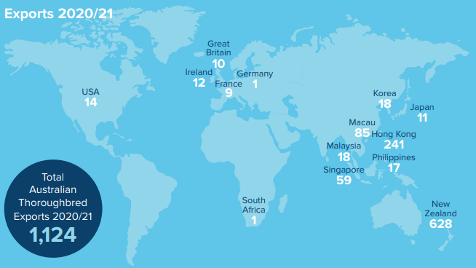
Source: Racing Australia (2021); Fact Book 2021; p.49

Skills shortages
Across the many roles in racing and breeding, there is an ageing workforce. AgriFutures, for example, found that 78% of people involved in breeding are over the age of 50. Industry is therefore focussing on attracting the next generation of workers, especially as there are current skills shortages. This is partly a reflection of career pathways having not been visible to potential industry participants (especially young people), as well as the predominance of smaller employers finding it difficult to support the costs associated with training or meeting all the requirements for apprenticeships and traineeships.

The National Skills Commission (NSC) regularly reviews the national skills needs of Australia and, from June 2021, has responsibility for releasing a Skills Priority List (SPL) annually. A key element of the SPL is the determination of occupational shortages, when ‘employers are unable to fill or have considerable difficulty filling vacancies for an occupation or cannot meet significant specialised skill needs within that occupation, at current levels of remuneration and conditions of employment and in reasonably accessible locations’. The NSC designates several racing and breeding occupations as not being in national shortage, but with a significant level of future demand:
Table 2: Industry Statistics
ANZSCO Code | Occupation | Current national shortage overall? | Future demand (five-year period)
361112 | Horse Trainer | No (shortage in NSW) | Strong
452318 | Dog or Horse Racing Official | No (shortage in NSW) | Moderate
361115 | Kennel Hand | No | Strong
361111 | Dog Handler or Trainer | No | Strong
452413 | Jockey | No | Moderate
121316 | Horse Breeder | No | Soft

Source: National Skills Commission (2021); 2021 Skills Priority List
It is worth noting that the SPL was published before the recent update of the Australian and New Zealand Standard Classification of Occupations (ANZSCO), which saw the creation or review of classifications for occupations such as track rider (see the case study below). Numerous stakeholders believe that, with the benefit of refined and improved classifications, future releases of the SPL will display shortages in a greater number of occupations associated with racing and breeding. It is also hoped that greater sample sizes may also identify shortages in occupations that are classified in the SPL as not being in shortage; for example, dedicated industry research in Western Australia defines that ‘There continues to be a small shortage of jockeys in Western Australia, however track riders and farriers occupations that underpin the sector are in short supply’.

Labour shortages have been exacerbated by racing and breeding occupations being reclassified from being ‘skilled’ on working visa lists, meaning fewer people are entering Australia to work in the industry. According to reports, this was part of a government strategy to lessen the reliance on international workers; however, combined with the effects of COVID-19-related restrictions, this has led to persistent shortages in occupations such as track rider and stable hand.

From their extensive industry engagement and networks, Industry Reference Committee members have stated that there are shortages relating to the following occupations:
- Jockeys, especially in regional areas of Queensland, Northern Territory and Tasmania, with a moderate shortage in New South Wales
  - This occupation or associated qualification is included on the state/territory government skills and priority occupation lists for QLD, NSW, NT, SA and WA
- Stablehands, especially in VIC
  - This occupation or associated qualification is included on the state/territory government skills and priority occupation lists for QLD, NSW, VIC and WA
- Dog or horse racing officials (including stewards), especially in WA
  - This occupation or associated qualification is included on the state/territory government skills and priority occupation lists for NSW, VIC and WA
- Stud workers (horse breeders, stud hands and stud grooms)
  - This occupation or associated qualification is included on the state/territory government skills and priority occupation lists for NSW, SA, TAS and WA
- Track riders
  - This occupation or associated qualification is included on the state/territory government skills and priority occupation lists for QLD, NSW, VIC and WA

Case Study: ANZSCO and Track Riders in the Racing Industry
The racing and breeding industry has strenuously been advocating for track riders to be reclassified to help address shortages in key states. Track riders provide crucial services by preparing racehorses for races under the instruction of horses’ trainers. The racing industry has faced persistent challenges in attracting enough track riders because of the physical nature of the work, high risk in exercising horses (especially in fast-work riding), timing of shifts (mostly in the early morning) and often casual and part-time contracts.

To address shortages, the industry previously relied on experienced, but unqualified, track riders on visas such as the Temporary Work Skilled Visa (Subclass 457). Government policy was later amended so that international workers were required to undertake training; however, industry stakeholders noted several barriers, including training being at too high an AQF level, Recognition of Prior Learning not being offered, and few RTOs delivering the RGR Training Package, especially in regional areas with thin markets and limited trainers.

While this situation was challenging, pandemic-related international border restrictions nullified the supply of workers and worsened shortages of track riders.

The ANZSCO update of track rider has changed it from being a sub-category of ‘stablehand’ under the ‘livestock farm workers’ grouping to being defined in its own right, alongside ‘horse trainer’, under the ‘animal attendants and trainers’ grouping. This has been welcomed by industry as the classification now reflects a key skilled job role that has been experiencing job shortages, and will potentially unlock opportunities for funding and worker attraction programs not previously available.

The varied roles, pathways and educational opportunities in racing and breeding
Racing and breeding are maintained and supported by a diverse range of occupations, as detailed in industry resources such as Thoroughbred Industry Careers’ directory, A-Z Careers, Harness Racing Victoria’s careers information guide, and Greyhound Racing Victoria’s information on career opportunities and position vacancies.

To attract the next generation of workers, industry participants are actively seeking to promote skills and training opportunities, and how these relate to career pathways. For example, Thoroughbred Breeders NSW initiated a workforce development project in 2020, which has focussed on ‘retaining existing staff, creating a training pathway for newcomers and upskilling the existing workforce’.
Figure 4: NSW Workforce Development Project
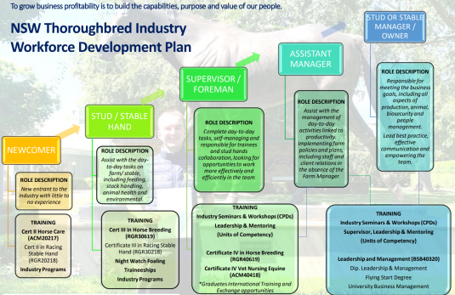
Source: http://www.tbnsw.com.au/news/nsw-workforce-development-project
The project team secured over $1,000,000 in NSW State Government funding, which was partially used to deliver free training to the breeding industry in the Hunter Valley. By the end of 2021, several nationally accredited programs commenced, and over 200 learners enrolled. Courses offered in 2022 include:
- Certificate III in Horse Breeding
- Certificate IV Horse Breeding
- Thoroughly Schooled: a high school work experience program
- Foaling Night Watch short course
- Short courses for leadership, mentoring and emerging supervisors, which comprise nationally recognised units of competency.
Thoroughbred Breeders NSW Executive Officer Julianne Christopher has noted, ‘Our goal is focussed heavily on retention and offering professional development training to the existing workforce, ultimately supporting national newcomer programs from Silverdale Farm Internships, TBA Fast Track and TIC Explorer Cadetships’. Wide interest and participation in the first phase of the program has led to plans for expanding to five additional locations, Goulburn Newcastle, Scone, Southern Highlands and Warwick Farm, to deliver the second phase, which commences in June 2022 (with expressions of interest now open).

There are a multitude of other industry-led educational initiatives to attract people to the racing and breeding industry:
- To provide training in trackwork riding, one of the most crucial and needed skills in the racing industry, Thoroughbred Industry Careers have created a formal education pathway called the ‘Accelerator Program’. The program offers practical, hands-on experience over 12 weeks of intensive training, after which learners will be guided into the workplace with the option of commencing the RGR30518 - Certificate III in Racing (Trackwork Rider) as a traineeship
- The Explorer Cadetship Program is an industry-led ‘gap year’ program, which starts with a 13-week residential stay to undertake the Certificate II in Racing, which is followed by two paid work experience placements at a racing stable and stud farm. Learning experiences include excursions to races, yearling sales, morning track work and stud farms, along with talks by trainers, jockeys, bloodstock agents, and administrators about their careers in the industry.
- To find the next generation of people to take up roles on studs across the country, Thoroughbred Breeders Australia has launched the Fast Track program. This 12-month traineeship opportunity includes employment, mentoring, and enrolment in the Certificate III in Horse Breeding
- The Silverdale Farm Intern Program, run in collaboration with TAFE NSW, is providing fully subsidised, on-stud capabilities development experiences through formal qualifications and schools programs. Interns are introduced to various opportunities for working on a horse breeding farm, as well as related careers in the racing industry, including through excursions to training stables, racetracks, and other industry businesses
- Racing SA, supported by the Government of South Australia and Skillinvest, is facilitating a Track Work Rider Skill Set Program to develop the skills and knowledge of new entrants to the industry. The course equips learners with skills and knowledge on fitness requirements, horse performance and health, animal welfare and compliance requirements. Completion of the RGRSS00077 - Thoroughbred Exercise Rider Skill Set provides learners with credit towards undertaking the RGR30518 Certificate III in Racing (Trackwork Rider) as a paid trainee
- Through its Off The Track program, Racing Victoria has announced a partnership with Marcus Oldham College to enrol people in the Diploma of Equine Management Program. As part of this program, Racing Victoria is educating people on its Equine Welfare Strategic Plan as well programs that transition retired racehorses to second careers
- Racing Victoria has introduced two pilot programs for industry upskilling and employment opportunities:
  - The Slow Trackwork Rider Course, delivered by Melbourne Polytechnic, is intended for people already working within the racing industry to develop skills as a trackwork rider. To address barriers to participation, the course runs one day per week over a 12-week period.
  - The Stable Start Program, delivered at Cranbourne Training Centre and Ballarat Racecourse, is intended for new entrants to gain practical experience working in a stable and around horses. It involves training one day per week for five weeks, with both online and face-to-face delivery.
  - Harness Racing Victoria has reviewed its Pony Trots program and introduced a further education component for career pathway transition to driver and/or a variety of roles within the industry. This unique positioning of a junior development pathway program introduces practical skill development, health safety and wellbeing, animal welfare, raceday operations, media and communication and integrity.

Such programs are being further supported by workforce development strategies in each state to ensure the alignment of training opportunities, learners’ work placements and employer incentives, as well as create pathways and information for secondary school students to enter the industry.

Training Summary

VET training products

RGR Qualifications
In 2020, there were 1,265 enrolments in RGR Training Package qualifications.

There were 207 qualification completions in 2020.
Figure 5: RGR Training Package Qualification Enrolments and Completions by Year
Source: NCVER VOCSTATS, TVA program enrolments 2015-2020
The greatest number of qualification enrolments in 2020 were in Victoria (819), followed by New South Wales (174) and Queensland (112).

RGR Units of Competency
In 2020, there were 7,572 enrolments in RGR units of competency (hereafter ‘units’). This includes enrolments through qualifications (in any training package), apprenticeships and non-apprenticeships, skill sets and micro-credentials.
Figure 6: RGR Training Package Unit Enrolments by Year
Source: NCVER VOCSTATS, TVA subject enrolments 2015-2020
RGR Training Package products are developed with collaboration across multiple industries. This results in numerous crossovers and importing and exporting of units to and from other training packages. Such transferability ensures the training system supports individuals to move easily between related occupations and sectors. Stakeholders have also noted that, in the absence of RGR qualifications from various RTOs’ scope of delivery, qualifications from other training packages, such as AHC32816 - Certificate III in Rural Operations, are being used for intended occupational outcomes in the racing and breeding industry.

Please see the Agribusiness, Food and Fibre Industries Skills Report for additional information on learners’ motivations for undertaking formal training, and employers’ use and views of VET and other forms of training.

Barriers to nationally recognised training
The Agribusiness, Food and Fibre Industries Skills Report summarises various challenges shared by all industries for the delivery of VET, especially in regional, rural and remote Australia. In the racing and breeding industry, there are no barriers greater than the lack of RTOs willing to continue delivering or develop new RGR training courses.

An example of training being discontinued is typified by the closure of the highly regarded Equine Section at Richmond TAFE from February 2022. Richmond TAFE delivered skills for horsemanship and safety for a vibrant equine industry in Hawkesbury, including a range of major horse breeding operations and horse racing. The courses, including Certificate II in Racing Industry, Certificate III in Racing (Stablehand), and Certificate III in Racing (Trackwork Rider), qualified people for occupations with skills shortages, including track riders. The decision to cease operations came amidst financial pressures to focus on high-volume training activities over those for niche industries, even in the context that the Equine Section offered learner outcomes, with a steady stream of skilled workers developed for the internationally renowned Godolphin stables.

The Gippsland Harness Training Centre (RTO Community College Gippsland), which was delivering Certificates II, III and IV from the RGR Training Package, closed at the start of 2022. This closure means that the Racing Education Centre is the only remaining RTO delivering harness racing-specific qualifications in Victoria.

Attracting new RTOs to deliver RGR training has likewise been unsuccessful because they cannot cover the costs of applying for approval to deliver qualifications and to develop and deliver new training and assessment products. This is because racing and breeding constitutes a thin training market, where the volume of participants is not great enough to fund the capital investment required of RTOs to access live animals, stables/kennels, tracks and equipment, while also implementing heightened safety procedures. There are additional challenges in providing lodgings for learners on rural, regional and remote breeding properties.

The work of IRC members and Principal Racing Authorities (PRAs) in encouraging RTOs to place RGR products on scope was severely disrupted during the COVID-19 pandemic. While many RTOs are operating again, persuading them to invest in the newly created and updated RGR qualifications has proven enormously difficult, and has been further hampered by the uncertainty caused by the potential deletion of ‘low enrolment’ training package products. It is clear that the work of PRAs to encourage RTOs to deliver formal training may not be successful prior to VET reform; however, in the forthcoming Industry Cluster system there will reputedly be functions for developing training and assessment resources on behalf of industry, a service that the RGR IRC have been requesting for some years.

Rural, Regional & Remote (RRR) Summary
The Agribusiness, Food and Fibre Industries Skills Report provides information on the many and intersecting challenges of stimulating industry growth and communities in rural, regional and remote areas. It is described how many racing and breeding enterprises are located in regional locations where access to skilled workers, and resources for inexperienced workers’ development, is limited. A lack of infrastructure, housing, public transport, health services, broadband and mobile connectivity, and access to education and skills training services makes moving to some locations an unattractive proposition, and businesses are forced to incentivise potential employees by offering higher wages, which can often be challenging financially.

Implementing the recommendations of the National Regional, Rural and Remote Tertiary Education Strategy (‘the Napthine Review’), as has been asked of Australia’s first Regional Education Commissioner, will complement the VET reform agenda as well as efforts by regional industries to improve productivity and profitability. The Transition Advisory Group are clear that businesses in regional areas must be adequately represented in the reformed VET system so that appropriate training is delivered where and when it is needed. This requires improving employer engagement with the national training system, creating collaborative relationships between employers and training providers, and working towards longer-term workforce development objectives.

Aboriginal & Torres Strait Islander Peoples Summary
The Racing and Breeding industry is increasingly introducing programs to assist in employment and participation by Aboriginal and Torres Strait Islander people. Participation has been steadily growing in the industry over the last decade.

Numerous States and Territories have awards or scholarship programs designed to attract Indigenous participants, and these are being supported by events such as “Racing on Country” days which celebrate Indigenous culture, which are being organised particularly in regional Australia. Regional centres have been seeking to work with local Indigenous communities to address worker shortages, particularly for track riders and stable hands.

A number of state, territory and local bodies have introduced or are working on Reconciliation Action Plans which have particular focus on building understanding of current Aboriginal and Torres Strait Islander staffing and developing business cases for Aboriginal and Torres Strait Islander future employment and professional development.

IBISWorld (2022); Horse and Dog Racing in Australia; p.11
IER (2021); Size and Scope of the Tasmanian Racing Industry; p.28.
Greyhound Racing Victoria (2022); Greyhound Microchip Registry – Information; https://greyhoundcare.grv.org.au/grv-microchip-registry/; viewed 31/08/2022.
Harness Racing Australia (2022); Microchip Technology Launch; https://www.harness.org.au/media-room/news-article/?news_id=53533; viewed 31/08/2022.
National Horse Traceability Working Group (2022); National Horse Traceability System Reform: Consultation Information; https://agriculture.vic.gov.au/__data/assets/pdf_file/0004/855661/NHTS-Consultation-Information_FINAL.pdf
Skills Impact (2021); Australian Racing and Breeding Industry Sector: Annual Update 2021; https://www.skillsimpact.com.au/stooveel/2021/06/ISF.RGR_.IRCSkillsForecast.2021AnnualUpdate.final_.pdf
Australian Government (2022); Australian biosecurity webinar series; https://www.awe.gov.au/biosecurity-trade/policy/australia/public-awareness/webinar-series; viewed 31/08/2022.
Thoroughbred Breeders Australia (2022); Key Issues & Achievements; https://www.tbaus.com/about-the-tba/current-issues/; viewed 31/08/2022.
AgriFutures Australia (2021); Search for silent carriers set to strangle disease transmission; https://www.agrifutures.com.au/news/search-for-silent-carriers-set-to-strangle-disease-transmission/; viewed 31/08/2022.
Queensland Racing Integrity Commission (2019); QRIC’s Animal Welfare Strategy; https://qric.qld.gov.au/wp-content/uploads/2019/07/QRIC-Animal-Welfare-Strategy-2016-2020.pdf
My Horse University (2017); Pasture Rotation; https://www.myhorseuniversity.com/single-post/2017/09/25/pasture-rotation; viewed 31/08/2022.
Thoroughbred Welfare Initiative (2021); The most important participant: A Framework for Thoroughbred Welfare; Report of the Thoroughbred Aftercare Welfare Working Group.
Harness Racing Victoria (2016); Equine Welfare Framework: A life worth living; https://integrity.thetrots.com.au/rules/policies/equine-welfare-framework/
Greyhounds Australasia (2021); Greyhound Welfare Strategy; https://galtd.org.au/welfare/greyhound-welfare-strategy/; viewed 31/08/2022.
Department of Agriculture and Fisheries, Queensland (2021); Land Transport of Horses; https://www.agforceqld.org.au/assets/consultation-paper-land-transport-of-horses.pdf
TOC (2022); Track Maintenance; https://www.toconline.com/publicationsmedia/article-archives-2/racing-your-horse/track-maintenance/; viewed 31/08/2022.
Weatherzone (2019); Heat stress on race horses in a changing climate; https://www.weatherzone.com.au/news/heat-stress-on-race-horses-in-a-changing-climate/530577; viewed 31/08/2022.
IBISWorld (2022); Horse Farming in Australia; p.31
CSIRO (2013); 3D printed horseshoe to improve racing performance; https://www.csiro.au/en/news/news-releases/2013/3d-printed-horseshoe-to-improve-racing-performance; viewed 31/08/2022.
Practical Horseman (2016); A Lift For Broken-Leg Recovery; https://practicalhorsemanmag.com/health-archive/lift-for-horses-with-broken-legs-53140/; viewed 31/08/2022.
Digitalgrog (2020); How Technology Is Changing The Horse Racing Industry; https://www.digitalgrog.com.au/sports/how-technology-is-changing-the-horse-racing-industry/; viewed 31/08/2022.
Techstory (2020); Technological breakthroughs in the horse racing world; https://techstory.in/technological-breakthroughs-in-the-horse-racing-world/; viewed 31/08/2022.
AgriFutures Australia (2021); Final report summary: Improving jockey safety through the use of virtual reality and biomarkers of concussion; https://www.agrifutures.com.au/wp-content/uploads/2021/09/21-060.pdf
Australian Rural & Regional News (2022); Concussion and stress research puts jockey safety in the saddle; https://arr.news/2022/03/09/concussion-and-stress-research-puts-jockey-safety-in-the-saddle/; viewed 31/08/2022.
IBISWorld (2022); Horse Farming in Australia
IBISWorld (2022); Horse and Dog Racing in Australia
Safe Work Australia (2014); Guide To Managing Risks When New And Inexperienced Persons Interact With Horses; https://www.safeworkaustralia.gov.au/system/files/documents/1702/horse-guide.pdf
NSW Government (2017); Code Of Practice: Managing Risks When New Or Inexperienced Riders Or Handlers Interact With Horses In The Workplace; https://www.safework.nsw.gov.au/__data/assets/pdf_file/0005/79160/SW08262-Code-of-Practice-Managing-risks-when-new-or-inexperienced-riders-or-handlers-interact-with-horses-in-the-workplace.pdf
Australian Rural & Regional News (2022); Concussion and stress research puts jockey safety in the saddle; https://arr.news/2022/03/09/concussion-and-stress-research-puts-jockey-safety-in-the-saddle/; viewed 31/08/2022.
AgriFutures Australia (2021; Final report summary: Improving jockey safety through the use of virtual reality and biomarkers of concussion; https://www.agrifutures.com.au/product/final-report-summary-improving-jockey-safety-through-the-use-of-virtual-reality-and-biomarkers-of-concussion/; viewed 31/08/2022.
Jockey’s Room (2021); National Jockey Safety Review; https://jockeysroom.racingnsw.com.au/wp-content/uploads/2021/04/National-Jockey-Safety-Review.pdf
Queensland Government (2022); $500k in flood relief for Queensland racing; https://statements.qld.gov.au/statements/94622; viewed 31/08/2022.
Racing Post (2022); 'The whole stable went under' - floods wreak havoc on Australia's east coast; https://www.racingpost.com/news/the-whole-stable-went-under-floods-causing-carnage-on-australias-east-coast/540693; viewed 31/08/2022.
Racing Queensland (2022); Capalaba impacted by floods; https://www.racingqueensland.com.au/news/march-2022/capalaba-impacted-by-floods; viewed 31/08/2022.
Racing Australia (2021); Fact Book 2021; p.2.
Thoroughbred Industry Careers (2022); The Industry; https://tbindustrycareers.com.au/the-industry/; viewed 31/08/2022.
AgriFutures Australia (2019); Measurement of economic impact of the Australian thoroughbred breeding industry; https://www.agrifutures.com.au/wp-content/uploads/2019/12/18-046.pdf
National Skills Commission (2021); Skills Priority List Methodology; p.5
FutureNow (2022); Industry Snapshot: Racing, Equine and Farriery
Racenet (2022); Racing Victoria renews push for labour shortage help; https://www.racenet.com.au/news/racing-victoria-renews-push-to-federal-government-for-work-visa-changes-20220914; viewed 26/09/2022.
FutureNow (2022); Industry Snapshot: Racing, Equine and Farriery
Thoroughbred Industry Careers (2022); A-Z Careers; https://tbindustrycareers.com.au/a-z-careers/; viewed 31/08/2022.
Harness Racing Victoria (2022); Careers in the Harness Racing Industry; https://www.thetrots.com.au/about-hrv/careers/brochure/
Greyhound Racing Victoria (2022); Career Opportunities; https://www.grv.org.au/positions-vacant/; viewed 31/08/2022.
Thoroughbred Breeders NSW (2022); NSW Workforce Development Project; http://www.tbnsw.com.au/news/nsw-workforce-development-project; viewed 31/08/2022.
Thoroughbred Breeders NSW (2022); Thoroughly Schooled Program Launched; http://tbnsw.com.au/news/thoroughly-schooled-program-launched; viewed 16/05/2022.
TAFE NSW (2022); Statement Of Attainment In Foaling Night Watch; https://www.tafensw.edu.au/course/-/c/c/900-81771V01/Statement-of-Attainment-in-Foaling-Night-Watch; viewed 16/05/2022.
Thoroughbred Industry Careers (2020); The Accelerator Program; https://tbindustrycareers.com.au/the-accelerator-program/; viewed 16/05/2022.
Thoroughbred Industry Careers (2021); Overview; http://tbindustrycareers.com.au/overview/; viewed 16/05/2022.
Thoroughbred Breeders Australia (2022); About The Fast Track Program; https://www.tbaus.com/fast-track-program/about-the-fast-track-program/; viewed 16/05/2022.
Silverdale Farm (2022); Silverdale Farm Intern Program; https://silverdale-farm-intern-program.com/; viewed 16/05/2022.
Racing SA (2022); Track-work Riding Skills Course; https://racingsa.com.au/careers/track-work-riding-skills-course; viewed 16/05/2022.
Racing Victoria (2021); Racing Victoria partners with leading equine college to support horse welfare education; https://www.racingvictoria.com.au/news/2021-07-27/racing-victoria-partners-with-leading-equine-college-to-support-horse-welfare-education; viewed 16/05/2022.
Racing Victoria (2021); New training programs to boost Victorian racing workforce; https://www.racingvictoria.com.au/news/2021-09-07/new-training-programs-to-boost-victorian-racing-workforce; viewed 16/05/2022.
Hawkesbury Post (2022); Equine courses axed at Richmond TAFE, leaving horse industry, students, and teachers stunned; https://www.hawkesburypost.com.au/post/equine-courses-axed-at-richmond-tafe-leaving-the-horse-industry-students-and-teachers-stunned; viewed 11/02/2022.
Skills Impact (2021); Australian Racing and Breeding Industry Sector: Annual Update 2021; https://www.skillsimpact.com.au/stooveel/2021/06/ISF.RGR_.IRCSkillsForecast.2021AnnualUpdate.final_.pdf; p.19
Infrastructure Australia (2022); Regional Strengths and Infrastructure Gaps Overview
Commonwealth of Australia (2019); National Regional, Rural and Remote Tertiary Education Strategy.
Transition Advisory Group (2021); Final Advice – New Industry Engagement Arrangements; Australian Government Department of Education, Skills and Employment; p.2.

