



Pulp and Paper Manufacturing

Industry Skills Report

Contents
Acknowledgement of the work of IRCs 3
Acknowledgement of Country 3
Purpose 4
Key Findings and Priorities 5
Industry Reference Committee 6
Method 6
Part 1 - Environmental Analysis 7
Whole of Value Chain Approach 7
Value chain interdependencies 7
Phasing out of native timber harvesting 8
Current crossovers and divisions of the value chain in the VET system 8
Biosecurity, Invasive Species and Pest Control 9
Climate change mitigation 9
The circular economy 10
Digital and Automation Practices 11
QA & Regulatory Compliance 11
Sustainability through certification 11
Workplace and Value Chain Risk Management and Safety Culture 12
Part 2 - Industry Summary and Trends 13
Workforce, Business & Market Summary 13
Induction of new entrants to the industry 13
Training Summary 15
VET training products 15
Barriers to nationally recognised training 15
Future directions 17
Rural, Regional & Remote Summary 17

Acknowledgement of the work of IRCs
We acknowledge the work of the members of Industry Reference Committee (IRC) in the preparation of this report and continuing phases of the project. Their voluntary participation and provision of intelligence and data makes the compilation of this information possible.

This report has been developed from six years of contributions from the Industry Reference Committee.

Acknowledgement of Country
Aboriginal and Torres Strait Islander peoples have a proud and continuous connection to Australia's land and waters. We acknowledge the traditional owners and custodians, and the continuing connection of Aboriginal and Torres Strait Islander peoples to the lands, waters and communities. We pay our respects to Elders and Leaders, past and present, and to all Aboriginal and Torres Strait Islander peoples who have supported our work.

We acknowledge the importance of learning from Aboriginal and Torres Strait Islander peoples’ unique history of land and ecosystem management, art, culture and society. Their connections are particularly important given our involvement in work directly connected to utilisation, care and stewardship of Australia's land, waters and ecosystems, and the animals, trees and plants that thrive across Australia.

The Industry Reference Committees and Skills Impact have been working to develop improved participation of Aboriginal and Torres Strait Islander enterprises, businesses, communities and people in our work. We will continue to work to develop strong, mutually beneficial relationships with Aboriginal and Torres Strait Islander partners who can help us deliver better outcomes for Aboriginal and Torres Strait Islander peoples, recognising their expertise in improving quality of life, employment opportunities and skills outcomes in their communities and for the whole of Australia.

Purpose
Skills Impact and ForestWorks have prepared this Industry Skills Report on behalf of the following Industry Reference Committees (IRCs):
- Pulp and Paper Manufacturing
It provides in-depth information about industry-specific skills and issues covered in the Agribusiness, Food and Fibre Industries Skills Report.

As one of nine industry-specific Skills Reports with matching structures, this document is designed to assist collaboration across industries and the streamlining and reform of the Australian skills and VET system. This may aid the implementation of the Skills Minister’s Priorities by supporting:
- greater labour mobility through stronger recognition of cross-sector and transferable skills
- better use of industry and educator expertise to ensure better quality outcomes
- improved pathways advice to support lifelong learning and build peoples’ labour market resilience
- Australia’s capacity to grow, compete and thrive in the global economy, especially in context of the concurrent impacts of COVID-19, automation and digital transformation on the skills required for jobs now and into the future.
The IRCs requested that this report be prepared to support improvements in the skills system, including work on:
- industry workforce planning and strategies to address workforce shortages
- documenting shared standards and regulations across industries to support end-to-end systems planning and avoid duplication
- the provision of evidence, data and intelligence to add value for industries beyond a narrow focus on training package development, and to inform future Industry Clusters or similar bodies approved to undertake work within the Australian skills and VET system
- creating foundations for potential qualification reforms with a greater emphasis on skills families and portable skills
- identifying shared ‘skills domains’ to aid in simplifying and streamlining national VET qualifications across industry groupings.

Key Findings and Priorities
Australia’s pulp and paper manufacturing industry continues to pursue and exceed sustainability and innovation goals despite the disruptions and impacts caused by COVID and its related supply chain issues, fibre supply uncertainties due to bushfires and harvesting bans, and global market impacts as a result of the war in Ukraine.

Key growth areas in the industry are packaging for food, retail goods and e-commerce, and converted paper product manufacturing. Digitisation and remote working have contributed to the steady decline of newsprint and general paper consumption.

The industry is investing heavily in capital and skills projects to support the circular economy, climate change mitigation and consumer demand. While investing in its own future, industry is also working in partnership with governments to address priorities as a key player in the delivery of Australia’s international environmental commitments and local consumer requirements.

The 2021 complete review of the Pulp and Paper Manufacturing Industry (PPM) Training Package was an important milestone in the IRC’s goal to have the qualifications accurately reflect the innovative and recent technology and operations of the businesses operating in the industry.

The IRC considers the Training Package to sufficiently reflect the functions of the industry and that priority work to support the industry will be in other parts of the skills system.

With respect to future work to support engagement with the VET sector, the IRC has identified priorities that they recommend for future consideration, including:
- Actions to implement identified solutions to address low enrolments and thin markets
- Development of industry shared resources to support delivery of accredited training
- Working with other agribusiness, food and fibre industries on research and planning projects to identify and address skills gaps relating to traceability, provenance and blockchain
- Identifying digital skills needs using the Digital Workforce Capability and VET framework currently in development (along with other digital capability frameworks).

Signed on behalf of Pulp and Paper Manufacturing Industry Reference Committee:


Chair: Denise Campbell-Burns
Date: 26 September 2022

Industry Reference Committee
The Pulp and Paper Manufacturing IRC is responsible for national training package qualifications relevant to pulp and paper manufacturing.

Qualifications overseen by the IRC are in the Pulp and Paper Manufacturing Training Package.

The Pulp and Paper Manufacturing IRC is supported by the Skills Service Organisation, Skills Impact.

Name | Organisation or Area of Expertise
Adele Elice-Invaso | APPITA Australian Pulp & Paper Industry Technical Association (APPITA)
Denise Campbell-Burns (Chair) | CFMEU Manufacturing Division
James Swan | Orora Group
Kylie Jones | Australian Paper
Tim Lester | Australian Forest Products Association (AFPA)
Scott Edwards | Norske Skog
Terry McDonald (Deputy Chair) | Visy

Method
Industry Reference Committees oversee the work of Skills Service organisations in the collection and analysis of industry intelligence, which is used to:
- Identify industry skills needs and challenges
- Identify issues and potential improvements to the Skills and VET system
- Provide the basis for work to update VET training package products
- Provide an information source for industry to assist with business, workforce, skills and training planning.
The information in this report has been collated from a variety of sources identified by Industry Reference Committee members and industry stakeholders who have participated in consultations with Skills impact. It also utilises data and information from official sources and major commercial providers through the assistance of the Australian Government Department of Education, Skills and Employment.

Part 1 - Environmental Analysis

This Environmental Analysis is intended to provide a link between industry trends and issues impacting the industry and the skills need relating to those issues and trends.

Whole of Value Chain Approach
Pulp and Paper business sit within value chains of significant importance to Australian consumers. The businesses receive materials and transform those materials through processes to deliver value to consumers. As a result, these businesses are within a number of different value chains across Australia and internationally.

Value chain interdependencies
Pulp and paper manufacturing operations in Australia are tightly embedded within the overall forest and wood products supply chain. The harvest of pulp logs for paper and cardboard manufacturer is only commercially and operationally feasible if higher-value timber for sawmills is also harvested. Upstream in the supply chain, forest operations continue to be severely challenged by impacts of bushfire, COVID, government policy and market fluctuations, and these in turn impact the pulp and paper manufacturing industry.

The pulp and paper manufacturing industry can be defined as having primary and secondary manufacturing sectors:

Primary Manufacturing
- Pulp, paper and paperboard manufacturing
  - businesses that mainly manufacture pulp, paper or paperboard from inputs such as woodchips, clay, lime, dyes, chemical resins and recycled paper.
Secondary Manufacturing
- Corrugated paperboard and paperboard container manufacturing
  - businesses purchase and convert paper and paperboard into corrugated paperboard containers, solid paperboard and packaging containers. Industry products include plain cardboard boxes, specialised packaging for various industrial and consumer goods, and beverage and food cartons. Finished products are mainly sold to other manufacturing industries, as well as to wholesalers, distributors and retailers.
- Paper bag and other paper product manufacturing
  - businesses manufacture paper bags and other paper products, e.g. adhesive labels and food packaging items.
- Paper stationery manufacturing
  - businesses purchase paper and paperboard from mills and process it into a range of office, educational and personal paper stationery products, including writing and filing materials, print and copy paper, paperboard games and toys, paper labels, and playing cards.
- Sanitary paper product manufacturing
  - businesses manufacture sanitary paper products such as tissues, nappies, napkins, towels and female sanitary goods. These products are typically sold to groceries, paper product wholesalers and directly to retailers.
- Paper product merchandising
  - businesses include wholesalers, manufacturers and merchants who sell, import and export large volumes of paper and paperboard, as well as paper-based packaging, stationery and sanitary products that are distributed through the merchant sector or directly to specialist industries.

All aspects of the pulp and paper value chain are supported by cross-sectoral skills, knowledge in logistics, and safety and regulatory compliance (each addressed in greater detail below). These technical skills are further enabled by employability skills in communication, strategic planning, data analysis, leadership, digital literacy, science, technology, engineering, and mathematics (STEM). Employers’ ability to access workers with such skills creates unique challenges and opportunities across the value chain. Long-term investment in the capabilities and skills of the pulp and paper manufacturing workforce is critical.

Phasing out of native timber harvesting
The Victorian Government has resolved to phase out native forest harvesting by 2030 (with reductions from 2024-25). This native timber logging ban on public lands is forecast to result in a deficit of wood supply and, to address this, the Victorian Government has committed to an extra 50,000 hectares for timber plantation by 2030. The WA Government has announced phased banning from 2024, initially in the South-West of the state.

In Victoria the impact on the pulp and paper industry is centred around the ongoing supply of pulp logs for the Opal Australian Paper Maryvale Mill. This mill takes waste product from hardwood sawmills and turns it into copy paper and packaging materials. With many hardwood sawmills already under pressure, the actions in Victoria are creating greater uncertainty around ongoing production at the Maryvale mill.

Industry is concerned that there will a be significant shortfall of available resource, not just for pulp and paper but for other forest and wood products, as any plantations established will not be ready for use by the time the ban comes into effect in 2030.

Current crossovers and divisions of the value chain in the VET system
Due to the PPM Training Packages’ reflection of the industry’s unique skills and knowledge, there are few cross-over points in the Australian VET sector between the pulp and paper manufacturing industry and related industries.

There are currently no instances of PPM units of competency being imported into other training packages, with the exception of state-based qualifications in Victoria. However, the PPM Training Package imports and utilises units from 14 different training packages:
- BSB Business Services Training Package
- CPP Property Services Training Package
- FWP Forest and Wood Products Training Package
- HLT Health Training Package
- MEM Manufacturing and Engineering Training Package
- MSS Sustainability Training Package
- MSM Manufacturing Training Package
- MSL Laboratory Operations Training Package
- NWP National Water Training Package
- PMA Chemical, Hydrocarbons and Refining Training Package
- PSP Public Sector Training Package
- TAE Training and Education Training Package
- TLI Transport and Logistics Training Package
- UEP Electricity Supply Industry – Generation Sector Training Package

Biosecurity, Invasive Species and Pest Control
Please see the Agribusiness, Food and Fibre Industries Skills Report for more details on the critical importance of and shared responsibility for biosecurity across the primary industries. Plant and animal (including pest control) biosecurity controls and skills are increasingly important to enact a continuum of biosecurity practices, including prevention, detection, containment, and eradication, that safeguard Australian communities and industries.

Australia has few significant pests that affect timber and forests in other countries because of its geographic isolation and robust border biosecurity systems. This has contributed to the successful development of the Australian pulp and paper industry and resulted in very low costs associated with pest management practices in the pulp and paper industry.

Climate change mitigation
The Food and Agriculture Organisation (FAO) of the United Nations released a State of the World’s Forests Report in May 2022 which reinforces that sustainable forestry is essential to help curb the global climate crisis and help avert major biodiversity loss.

The industries that are Australia's forestry and wood products, including pulp and paper, play a major role in mitigating climate change, growing regional communities and stimulating economic activity. The overall shift towards cardboard and paper products for packaging of consumer goods, foods and fresh produce will support climate change mitigation goals. As a result of the expected increase in demand, Opal Group have announced that it will build a state-of-the-art manufacturing facility for corrugated cardboard packaging in Wodonga, NE Victoria. The facility will include solar power and water harvesting capabilities.

There is Australia-wide support for increasing plantations both to meet increased domestic and global demand for wood and fibre and to transition to a greener, lower-emission economy. Research shows the need for at least 400,000 hectares of new plantations by 2030 to meet Australia’s demand for wood, in addition to the 70 million trees planted every year to replace the trees harvested in Australia’s plantations. Under the National Forest Industries Plan (2018) the Australian Government has a target for the planting of 1 billion extra production trees by 2030.

Principal Economics reports that potential carbon sequestration associated with the proposed plantation forestry expansion could significantly contribute to Australia meeting its net zero emissions target by 2050. The report asserts that forestry is one of the most efficient and effective methods of sequestration, and plantation expansion would help Australia meet its future wood needs, increase carbon stores in the built environment, and contribute to the circular economy through the sustainable, renewable and recyclable potential of timber products.

The paper production process requires a large amount of energy. The process also generates carbon dioxide emissions and creates waste products that need to be processed. However, the industry has developed innovative technologies and processes to create its own energy and to re-use and recycle throughout the production stages that lessen its reliance on fossil fuels.

One example of a significant initiative to reduce reliance on external provision of gas and electricity, and secure energy requirements for the future is the Maryvale Energy from Waste (EfW) project. The facility will process 325,000 tonnes of residual waste that would otherwise be lost to landfill. It will reduce greenhouse gas emissions in Victoria by an estimated 270,000 tonnes. Construction of the facility is planned to commence in 2022.

The circular economy
The PPM industry continues to be at the forefront of the push for a circular economy where the cycle of ‘make, use, dispose’ is replaced by the philosophy for ‘reusing and recycling’, thus extracting maximum value from materials and resources largely eliminating waste. Transitioning to a circular economy involves changing industrial practices to exploit bioenergy and biomass opportunities.

When taken into context around China’s ban on the importation of recyclable waste in 2018, the need for innovative solutions to progress to a circular economy remains high.
Figure 1: Circular economy
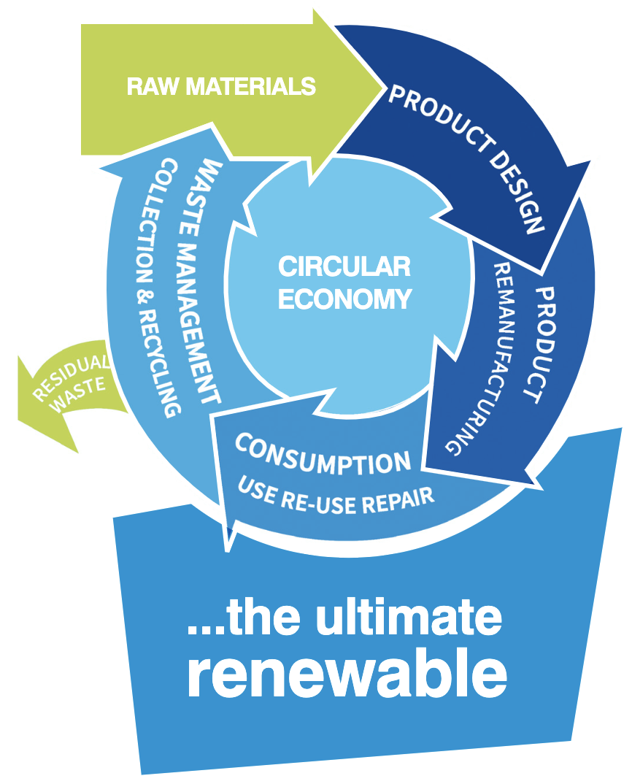
Source: Australian Forest Products Association (2018);
2018 National Pulp and Paper Industry Sustainability Report
In addition to the energy from waste facility and the new cardboard manufacturing facility referred to earlier, a market leading tissue product manufacturer has recently installed updated machinery. Further capital expenditure commitments across the industry are expected, and the industry is continuing to demonstrate that innovation and sustainability are its core values.

In response to emerging industry needs, The Victorian Government is supporting skills needs through the Workforce Training Innovation Fund. One funded program is BioPathways, a strategic partnership with Opal Australian Paper, Federation Training and Federation University to support Gippsland’s future bioprocessing training needs. This project developed state-based qualifications related to bioprocessing.

In addition, the complete review of the PPM Training Package in 2021 held a particular focus on recovered paper operations, with units of competency now incorporating or reflecting these operations.

The recovered paper sector and projects that utilise household waste to produce energy are developing sectors that are moving at a fast pace to meet community expectations with regard to the recycle and re-use ethos. This level of industry development will require innovation and capacity to respond to the skills needs associated with the emerging technology and the requirement for workers with skill sets that may not meet the traditional pulp and paper profile.

Digital and Automation Practices
Please see the Agribusiness, Food and Fibre Industries Skills Report for additional information and data on digital and automation practices, including the Agricultural Workforce Digital Capability Framework, digital ecosystems (including connectivity issues in regional areas) and digital and automation skills delivery.

QA & Regulatory Compliance
Please see the Agribusiness, Food and Fibre Industries Skills Report and the PPM Pulp and Paper Manufacturing Training Package Implementation Guide for more details on legislation, environmental regulations, industry codes of practice, and information on regulated occupations. These documents detail the complex knowledge and skills requirements for compliance with forest policy in Australia, which is developed and implemented at the national, state and territory levels. State and territory governments have primary responsibility for forest management.

Sustainability through certification
Current certification schemes and industry codes of practice regulate how forests and products produced from forests, including paper and paper products, are managed across Australia. They contain stringent requirements for protecting ecosystems and maintaining biodiversity, and cover issues such as forest carbon cycles, soil and water resources, plant and animal populations, waste management, the use of chemicals, and genetic diversity.

Certification gives customers confidence that the products they buy are based on sustainable forestry operations and good management practices. For a forest to be certified as sustainably managed, an audit is undertaken by an independent third-party certification body. The audit assesses the forest management practices of a forest manager or owner against the standard for certification.

For certification, audit and quality purposes, businesses need to implement a chain of custody certification system, including a register of documents that can include timber source information, processing records, quality records, and details for numbering/labelling systems. These processes ensure the traceability of products as they move through the supply chain. For Pulp and Paper manufacturers, meeting key requirements for sustainability focus on housekeeping, resource optimisation and applying waste disposal, recycling and re-use guidelines.

Australia has two active certification schemes:
- Australian Forestry Standard (AFS) now known as Responsible Wood – recognised through the Program for Endorsement of Forest Certification (PEFC)
- Forest Stewardship Council

More than 95% of the wood fibre used in the manufacture of pulp and paper and paperboard in Australia is from forest certified by either the Responsible Wood or the Forests Stewardship Council (FSC) and in some cases, by both.

Workplace and Value Chain Risk Management and Safety Culture
Safety has always been a key focus across all job levels within the pulp and paper manufacturing industry.

Production workers, operators and technicians need to be trained to follow and apply procedures and work practices covering a wide range of safety matters, including:
- equipment operation and isolation
- emergency and evacuation procedures
- use of safety and first aid equipment
- wearing of personal protective equipment and clothing
- hazard identification, risk control and mitigation, handling and elimination of hazardous materials and substances
- manual handling, including shifting, lifting and carrying
- fatigue management.
Some pulp and paper facilities are classified as Major Hazard Facilities due to the large amounts of chemicals and hazardous materials used and stored on site. Major Hazard Facilities have specific WHS duties and responsibilities, in addition to general WHS duties and responsibilities.

Part 2 - Industry Summary and Trends

Workforce, Business & Market Summary
The pulp and paper manufacturing industry remains a key employer in regional communities.

Businesses operating in the industry are highly concentrated in regional Victoria and New South Wales, with around 75% of industry business located in these two states and the remainder in South Australia, Tasmania and Queensland. Approximately half of the jobs sustained by this industry are located in regional Australia.

The industry directly employs over 15,000 people, but that number rises to around 30,000 people when taking into account the five large-scale multinational companies and 1,000 paper product wholesaling businesses. The sector also supports thousands of jobs in regional areas, including transport, logistics and supply chain operations. This means that many businesses exist in the town because the mill does.

The Pulp and Paper Manufacturing industry generated $10.75 billion in revenue and contributed $2.51 billion to Australian gross domestic product (‘industry value added’) in the financial year 2021-2022.
Table 1: Pulp and Paper Manufacturing Industry Financial Activity
Revenue ($billion) | Industry Value Added ($billion) | Businesses | Employment
$10.75 | $2.51 | 619 | 15,291

Source: IBISWorld Industry Wizard, 2022

Induction of new entrants to the industry
The Pulp and Paper Manufacturing Industry is characterised by a very stable workforce with low attrition rates. However, the workforce is ageing, and the industry is examining ways to attract new entrants over the next decade.

As shown in Figure 2 below, 40% of the workforce is over the age of 50. There will need to be a concerted and strategic approach to induct and train new entrants into the industry as the ageing workforce retires.
Figure 2: Age of Workforce
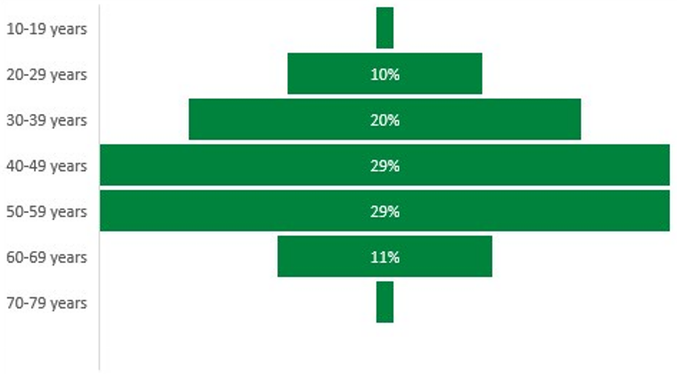
Source: 2016 Census of Population and Housing

As part of the recent review of the PPM Training Package, new units were developed that will provide new entrants (and some existing employees) with an understanding of industry structure, the principles of pulp and papermaking, and the processes used for papermaking and converting.
- PPMIND201 Apply principles of pulp and papermaking to work practices
- PPMIND202 Work effectively in the pulp and paper industry
The National Skills Commission (NSC) regularly reviews the national skills needs of Australia and, from June 2021, has responsibility for releasing a Skills Priority List (SPL) annually. A key element of the SPL is the determination of occupational shortages, when ‘employers are unable to fill or have considerable difficulty filling vacancies for an occupation or cannot meet significant specialised skill needs within that occupation, at current levels of remuneration and conditions of employment and in reasonably accessible locations’. Occupations designated by the NSC with shortages and significant future demand in the pulp and paper manufacturing industry are:

ANZSCO Code | Occupation | Current national shortage overall? | Future demand (five-year period)
712916 | Paper and Pulp Mill Operator | No | Moderate
133512 | Production Manager (Manufacturing) | No | Moderate
711311 | Paper Products Machine Operator | No | Moderate

Training Summary

VET training products
No RTO currently has PPM Training Package qualifications or units on scope, and this has been the case over the last four years. This means there are currently no enrolments in PPM qualifications or units of competency.

The graph below shows that in the decade 2003-2013, there were, relative to the size of the industry, healthy enrolment statistics across a range of PPM qualifications.

Examination of the factors that would have contributed to this include:
- In 2003-2013, training packages were supported through publicly funded development and availability of learning and assessment materials. Over the last decade, there has been no national funding for the development of industry-owned learning and assessment materials to support the delivery of units of competency and qualifications. In a thin training market, RTOs are hesitant to develop full sets of training and assessment materials, which are required to put qualifications and units on scope.
- Also, from 2003-2013, the pulp and paper industry was in partnership with an RTO providing inhouse use of the PPM training package using workplace trainers and assessors. RTOs are hesitant to utilise workplace trainers and assessors due to more stringent regulation and compliance requirements.
Figure 3: Enrolments in PPM Qualifications between 2003 and 2020
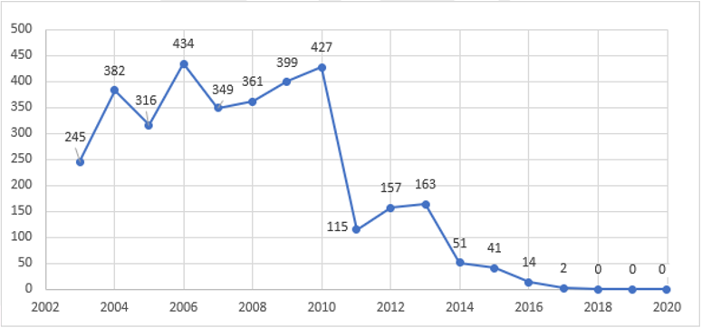
Source: NCVER VOCSTATS

Barriers to nationally recognised training
The traditional VET model doesn’t suit our industry. RTOs don’t have PPM machinery onsite for students to come to them. Nor do they have staff that know how to operate the specialised equipment and machinery used in PPM operations. What we need is a workplace-based and workforce-based training and assessment system that provides the rigour and calibre the VET system is renowned for but allows for flexibility and viability through effective partnerships between business and RTOs.
Denise Campbell Burns, Chair, PPM Industry Reference Committee

As consistently reported in previous Skills Forecasts, the industry is using the PPM Training Package informally and is actively seeking ways to stay engaged with the VET sector by attracting RTOs to service the sector. The main contributing factors identified with attraction and retention of an RTO are:
- unmet demand for ‘flexible’ training and assessment
- RTO viability challenges, especially relating to:
  - compliance
  - perceived risk of using workplace trainers and assessors and the increased requirements for workplace trainers and assessors
  - lack of developed training and assessment materials
  - access to specialised equipment
  - thin markets in regional areas
  - government funding models.

The image below shows the pathway that the IRC has mapped out to re-engage with the VET sector. After the review of the PPM Training Package (completed in 2021) and the identification of a workforce-based and workplace-based training and assessment strategy, the current step is to attract a willing RTO to service the sector.
Figure 4: PPM IRC pathway to re-engage with the VET sector
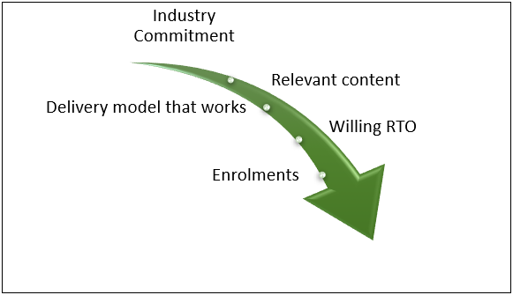
Source: PPM IRC and ForestWorks

For PPM businesses, the benefits of training using this type of model include:
- training and assessment can be delivered on site – minimising the time away from the workplace
- training that is highly relevant and specific rather than generic or broad-based
- training is delivered by industry experts.
Employers report that low enrolments are not a reflection of the quality of the training package but rather a lack of access to RTOs who can deliver the training flexibly while meeting specific workplace needs. This is partly due to the low financial viability for RTOs in continuing to offer such training when there is a relatively low workforce turnover and hence a low or inconsistent pool of new enrolees. This is commonly known as a thin training market.

In a project undertaken by Skills Impact and ForestWorks in 2020 to understand low enrolments in the industry, all RTOs reported that:
- Government funding arrangements do not include enough consideration of the additional costs for RTOs in thin, regional markets with specialised equipment requirements to make training viable to deliver.
- RTOs have high compliance requirements, which compounds difficulties associated with marketing and business development and attracting experts to become trainers and assessors.
- RTOs are unable to offer salaries and wages for trainers and assessors that are anywhere near what experienced operators earn in industry jobs.
- The current TAE qualification requires learners to design and develop assessment tools, which leaves many operators feeling that the paperwork requirements of trainer and assessors is overly burdensome. This is also impacting operators in the industry who hold earlier versions of the TAE but are unwilling to upgrade.

Future directions
Partnerships between RTOs and businesses utilising a workplace-based trainer and assessor model are seen as the solution to improving the disconnect between businesses and the VET system, and the PPM IRC, and industry stakeholders are pursuing this option through a number of approaches including:
- development of industry-based materials that can support units and qualifications in the PPM training Package
- alignment and mapping of industry-based resources to units of competency to support RTOs
- strategies and projects that can assist, encourage and support workplace experts to become and remain workplace-based trainers and assessors.
The above strategies have been explored and progressed with funding and funding opportunities from the Victorian State government.

Stakeholders have reported that industry experts would be attracted to becoming VET teachers and workplace assessors if the process of achieving the required TAE qualification was simplified and the model of workplace delivery with oversight and mentoring through an RTO was supported. The Industry is monitoring both the review of the TAE qualifications and the directions of the national regulator ASQA in these areas.

For many businesses, accessing information about nationally recognised training availability, funding and opportunities is complex and overwhelming. The Improving Enrolments Employer surveys suggest 75% of employers would like to see the provision of assistance to engage with RTOs and to access government funding for training.

In recent years, the Tasmanian Skills Development Service (TSDS) (now completed) has provided funding for any training that is of benefit to the industry (not just full qualifications). The program funded 3,289 training places and had a completion rate of 98%. One of the main features of the program was to provide support and assistance to industry businesses to engage with an RTO for training. Such programs have been welcomed by the sector and are seen as exemplars for future collaboration. The PPM IRC, therefore, welcomes the broadened scope of work that may be available under the proposed industry cluster arrangements.

Rural, Regional & Remote Summary
Please see the Agribusiness, Food and Fibre Industries Skills Report for information on the many and intersecting challenges of stimulating industry growth, communities and skill and training opportunities in rural, regional and remote areas.

ABC News (2019); Victorian Government announces multi-million-dollar plan to end native logging by 2030; https://www.abc.net.au/news/2019-11-06/native-timber-logging-in-victoria-to-be-phased-out-by-2030/11678590; viewed April 2020.
Australian Forest Products Association (2022); Sustainably managed, working forests, vital for halting deforestation and delivering climate goals; https://ausfpa.com.au/sustainably-managed-working-forests-vital-for-halting-deforestation-and-delivering-climate-goals/; viewed 04/05/2022.
Australian Forest Products Association (2022); National Farm Forestry Strategy Submission
Principle Economics (2022); Potential for carbon sequestration in Australian plantations forests to contribute to Australia’s ‘net Zero by 2050’ target; Australian Forest Products Association.
Australian Forest Products Association (2022); National Farm Forestry Strategy Submission
Australian Government (2022); VETNet: Pulp and Paper Manufacturing Training Package; https://vetnet.gov.au/Pages/TrainingDocs.aspx?q=12998f8d-d0ac-40bc-a69e-72a600d4fd93; viewed 01/09/2022.
AFPA (2018); National Pulp and Paper Sustainability Report
National Skills Commission (2021); Skills Priority List Methodology; p.5

