Agribusiness, Food & Fibre Industries Skills Report

Key Observations and Intelligence Summary


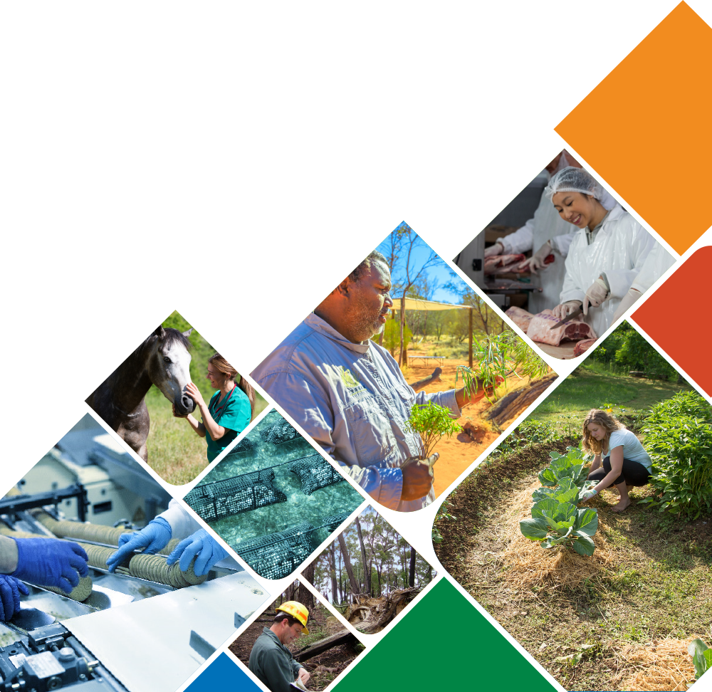

Purpose
At the request of 12 Industry Reference Committees (IRCs), Skills Impact has prepared an Agribusiness, Food and Fibre Industries Skills Report, which is designed to support collaboration across industries and the streamlining and reform of the Australian Skills and VET system.

This document is a complementary resource to the Agribusiness, Food and Fibre Industries Skills Report. Page references within this document direct readers to specific topics in the Industries Skills Report.

The Industries Skills Report may aid the implementation of the Skills Minister’s Priorities by supporting:
- greater labour mobility through stronger recognition of cross-sector and transferable skills
- better use of industry and educator expertise to ensure better quality outcomes
- improved pathways advice to promote lifelong learning and build peoples’ labour market resilience
- Australia’s capacity to grow, compete and thrive in the global economy, especially in context of the concurrent impacts of COVID-19, automation and digital transformation on the skills required for jobs now and into the future.

Coverage
The Industry Skills Report identifies common and shared issues across the Agribusiness, Food and Fibre Industries. This group of industries comprises:
- Agribusiness
  - including agriculture, horticulture, ecosystem management, animal care, aquaculture, fishing, racing, and business leadership and management
- Food
  - including food processing, baking, beverage production, brewing, distilling, wine, meat and seafood
- Forestry and fibre
  - including forest management and harvesting, pulp and paper, timber products, and building and furnishing solutions

Critical Themes Summary
The Agribusiness, Food and Fibre Industries are connected by a complex value chain that is critical to the ongoing function of all sectors and for ensuring Australians can maximise the benefits of our capacity to grow food and materials and manage our environment. There needs to be broader recognition of the risk profile across this value chain and the role of risk management as a defining characteristic of the skills used in these industries.

The health and growth of regional, rural and remote Australia is integral to the ongoing viability of Agribusiness, Food and Fibre Industries. Regional, rural and remote communities continue to face a range of employment and skill development challenges well beyond those experienced by the 64% of people in Australia who live in cities.

Approaches to address skilling issues suitable for cities rarely succeed in thin training markets in regional, rural and remote areas, where there are widely dispersed populations with variable skill levels. Recognition of the need to manage employment and skills development in the context of Agribusiness, Food and Fibre, and of the unique challenges faced in regional, rural and remote areas, are critical success factors in the implementation of solutions.

If we do not recognise and respond appropriately to the challenges experienced by employers and workers in Agribusiness, Food and Fibre Industries, especially in regional, rural and remote areas, all Australians end up paying for the resulting productivity losses, higher costs, reduced quality and diminished liveability associated with inadequate skills for these critical industries.

Defining Characteristics of the Agribusiness, Food and Fibre Industries
Industry bodies have been working to identify the scope of the Agribusiness, Food and Fibre Industries with a view to meeting the needs of a modern Australian skills system. This work started with the identification of industries in the National Agricultural Workforce Strategy, which was released in 2021 and subsequently endorsed by the Federal Government. It has been continued by industry stakeholders. Detailed pp.9-10

In the Industry Skills Report, the defining characteristics of the Agribusiness, Food and Fibre industries are identified as:
- whole of value chain approach
- biosecurity, invasive species and pest control
- sustaining plants and animals
- ecosystem management
- digital and automation practices
- food safety, quality assurance and regulatory compliance
- farm and value chain risk, safety culture. Detailed pp.9-8
The specific nature of the Agribusiness, Food and Fibre Industries requires a heightened focus on the risks associated with work tasks. Learners and educators need to understand and plan for risk. Key contributions from industry stakeholders include identifying commonalities across occupations and the inclusion of risk management as a defining characteristic of a skill. Detailed p.12

Environmental Analysis
A whole of value chain approach is essential not only for understanding the ways in which industries work together but also to implement robust and adaptable systems now and into the future. Detailed pp.11-12

The National Agriculture Workforce Strategy notes that if Australian Agribusiness is to become a $100 billion sector, a new approach will be essential. The strategy recommends a fundamental reimagining of agribusiness as a complex, modern, sophisticated sector that encompasses value-adding, supply chain considerations, consumer-driven approaches, sustainability issues, and adoption of field robotics and automation. Detailed pp.13-14

The Agribusiness, Food and Fibre Industries need to work with other industries to take mutual responsibility as products move along the value chain to the consumer. There are numerous intersecting interests and areas of regulation. There is a need to shorten and streamline Australia’s Agribusiness, Food and Fibre supply chains, inclusive of risk management strategies, to locally produce more fresh food and process more food, beverage and medicinal products. Detailed pp.13-16

The Agribusiness, Food and Fibre Industries have some of the most complex business planning, finance and investment, and workforce development challenges in Australia. These industries are subject to the vagaries of the natural environment, and businesses must respond to unpredictable weather, climate, water availability and natural disaster conditions such as fires, floods and pestilence. Detailed pp.13-16

Consumer demand, and local and international markets, are largely beyond the control of producers, employers and employees. Markets change over time in line with government planning and ‘social licence’ relating to land and water quality and use, demand for ethical production, cultural promotion and protection, conservation, heritage, and recreational and tourism needs. Detailed pp.13-16

Traceability and provenance are critical for national and international consumer markets, compliance, safety and welfare, licensing and prevention of fraud. Developing the skills and knowledge required to understand and operate blockchain technology may serve to ensure that the broad needs of industry are met. There may be a need for innovative development across multiple training packages. Detailed pp.17-21

Looking at the whole value chain helps to identify priority work on cross-sector projects, including collaboration with the manufacturing, transport and logistics, textiles, furniture, tourism and hospitality industries. The Federal Government's remodelled backpacker visa scheme is aimed at encouraging an influx of international visa workers, who are required to work in agribusiness, food, fibre, tourism or hospitality to fulfil the requirements for visa extensions. Detailed pp.23-25

Current training products relating to biosecurity have performed well while facing the major challenges of extreme climate conditions, floods, bushfires and the pandemic between 2019 and 2021. Industry Reference Committees have been seeking constant feedback on changes to training products; however, skills gaps relating to biosecurity in the products have not been identified. Detailed pp.25-30

The variety of standards and knowledge required to work with individual plant and animal species makes it difficult to simplify and streamline training products in their current configuration and format – despite the skills often being similar. Industry stakeholders have emphasised the importance of training package content being designed to enable contextualisation to address this issue. Detailed pp.30-32

Allied health services for animals, such as physiotherapy and massage, is a growing market, as are care, grooming and accessory services and products for companion animals. These are no longer niche markets; however, as emerging markets, there is limited data available on their size and growth. There may be a need to further develop training and assessment to ensure that appropriate levels of animal welfare standards are applied. Detailed p.33

There is a particular concern in Agribusiness, Food and Fibre for strengthening and diversifying regional and rural livelihoods and creating circular local food economies. Despite many positive developments in sustainability across these industries, social media misinformation and activist groups are threatening the social license of Agribusiness, Food and Fibre businesses. At times, this is even threatening the livelihoods and safety of businesses and employees. Stakeholders are increasingly requesting training for dealing with social media misinformation and activist groups, especially as these sources are receiving greater attention from the mainstream media. Detailed pp.30-38

Ecosystem management must take into account how actions in one sector can have knock-on effects throughout the value chain. Success is dependent on the buy-in of industry leaders across the industry cluster. Transformation and collaboration, however, has the potential to be undermined if major retailers continue to dominate the market (including with the use of blockchain) and drive down prices, leaving primary producers with smaller returns to develop and invest in their businesses. Meanwhile, endeavours to diversify and so strengthen regional, rural and remote industries must be encouraged in order for those economies to develop the capacity to support transformation. Detailed pp.30-37

Aboriginal and Torres Strait Islander communities, business enterprises and individuals are now major employers of workers or service providers in the ecosystem management sector. This has not only increased employment opportunities for Aboriginal and Torres Strait Islander peoples but has also led to changes in the ways in which work is undertaken. Various industry stakeholders are now recognising the importance of developing closer working relationships with Aboriginal and Torres Strait Islander communities and business enterprises. Detailed pp.39-42

So much is uncertain and unpredictable in this business environment that opportunities to provide some certainty should be seized. This has led to growing and now widespread support (along with continuing opposition) for a target of net zero emissions by 2050. Providing certainty about the target allows implementation of planning and the opportunity to understand the practical impacts. Inaction could see Australian food and fibre products subject to reputational damage and additional tariffs internationally. Detailed p.40

Water trading and regulation is a growing sector in Australia. A project is underway to develop training products that will deliver skills to understand and work within the complex regulatory environment, as well as negotiate and trade water for all purposes across Australia. There may be a need for projects to be developed for additional water trading skills, including negotiating access to water under Aboriginal and Torres Strait Islander custodianship. Detailed pp.41-43

While often early and enthusiastic adopters of technology, industries in regional, rural and remote areas experience connectivity issues that can prevent the rollout of digital technologies. Industries in this cluster are also reporting shortages of the skilled workers that would help them take full advantage of digital practices, automation and robotics. Detailed pp.43-49

Industry leaders support the development of the proposed VET Digital Capability Framework, which the Agriculture and Production Horticulture IRC has been testing in 2022. This is complementary to the Agriculture Workforce Digital Capability Framework co-authored by Skills Impact and released in 2019. In 2021, the Australian Industry and Skills Committee (AISC) approval and Australian Skills Ministers’ endorsement was confirmed for a new nationally recognised qualification, AHC51920 Diploma of Agronomy, to address the lack of specialist agricultural advisers with digital capabilities and to assist farmers and business operators to identify and source technology to meet their needs. Detailed pp.43-49

Sectors within Agribusiness, Food and Fibre face specific environmental regulations, codes of practice and guidelines which need to be addressed through skills development. With the number and complexity of food safety regulations, codes of practice and guidelines, it is extremely difficult for new sectors to become established quickly. Detailed pp.41-46

A panel reviewing Australia's agricultural and veterinary chemicals has recommended significant changes to the current approach, which will need to be supported with updated training products. The panel recognised that education and training plays a key role in ensuring that pesticides and veterinary medicines are handled and deployed safely and effectively. Detailed pp.55-56

All industries share the aspiration of achieving risk management and safety cultures. To develop safety skills, Agribusiness, Food and Fibre will need to work collaboratively across industries, while attending to the differentiating features of this cluster. Among workers, people 50 years of age and over accounted for almost 50% of all on-farm non-intentional injury deaths between 2001 and 2015. The farming industry has an ageing workforce, with many farmers continuing to work well beyond what is considered ‘normal’ retirement age in other sectors. Injury is the second leading cause of death among Aboriginal people working in agriculture, especially in grain, sheep and beef cattle farming. Death caused by injury occurs at three times the rate of non-Aboriginal farm workers. The three main categories of non-intentional injury deaths are transport deaths, drowning and poisoning. Detailed pp.59-61

Natural disasters have major impacts on many industries, but particularly the Agribusiness, Food and Fibre Industries due to their location and primary production. Improving risk management strategies and enhancing the overall safety cultures across industries, especially in regional, rural and remote Australia, is likely to mitigate some of the devastating effects of natural disasters on both populations and industries. Detailed pp.61-62

Market
Agribusiness, Food and Fibre businesses are mainly market driven, but some are based on delivery of social amenity. Even in those sectors, competitive market processes are often used for service provision. Detailed p.63

The Agribusiness, Food and Fibre Industries contribute to Australia's food security, our homes, health and wellbeing. They produce essential food, drink, medicine, fibre and textile products. They also work with and protect Australia's environmental assets, now valued at more than $6.5 trillion according to the Australian Bureau of Statistics and CSIRO. Detailed p.63

Overall, the Agribusiness, Food and Fibre Industries have a total revenue of almost $432 billion and contribute over $96 billion to overall GDP. Detailed p.63

The Agribusiness, Food and Fibre Industries are critical for rebuilding Australia’s economy and creating jobs in RRR areas, and this rebuilding relies on developing the skilled workers that can sustain them. The National Agricultural Workforce Strategy notes that the best way of future-proofing the Agribusiness, Food and Fibre industries is by preparing all levels of the workforce through ‘learning in all its forms, at all levels, in all the relevant parts of the nation’. Detailed p. 63

There has been a growing trend of seeking market solutions to challenges with environmental and resource management and protection. Water trading has evolved into a multifaceted market with an annual value estimated at more than $1.5 billion. Trading in carbon credits and hydrogen investments represent other rapidly expanding markets. Carbon credit units increased by 5% in the first half of 2021, meaning supply was on track to reach 17 million by the end of the year. Being visibly active in climate protection and sustainable production is becoming more powerful as a marketing tool for reaching consumers and increasing return on investment, and for maintaining international trade. Detailed pp.67-68

There are a growing number of markets that continue to be hidden from standard market analysis sources. This occurs for a number of reasons, such as because they are emergent markets or have historically been considered smaller contributors to larger markets. Detailed p.68

Business & Workforce
The Agribusiness, Food and Fibre Industries continue to be constrained by widespread labour shortages, jeopardising the short- and long-term viability of many businesses. Despite various industry schemes to attract local workers to careers in the Agribusiness, Food and Fibre Industries, there has so far been limited uptake of these careers by domestic workers. Detailed pp.68-81

The Agribusiness, Food and Fibre Industries account for around 8% of total employment nationally, which includes a significant proportion of regional and remote workforces. There are around 244,000 individual businesses, which operate and trade in all states and territories, and comprise a variety of small, medium and large enterprises. The sectors across these industries are extremely varied, with large agribusinesses, as well as niche, specialist and regional operators. The industries form a sophisticated and complex web across the value chain. Labour is a key input in the Agribusiness, Food and Fibre Industries. However, average employment figures do not accurately capture the complexity and variability of these workforces. It may be that more consideration needs to be given to the nature and flexibility of work in regional, rural and remote Australia. Detailed pp.68-70

The recent review of the Australian and New Zealand Standard Classification of Occupations (ANZSCO) went some way towards more clearly identifying current occupations in the industries. Better reflection of the breadth of careers and skills will benefit government and industry programs that aim to reframe misconceptions about industry jobs. It will also help industries address critical shortages that have inadvertently been sustained through occupations being mis-classified in the ANZSCO. Detailed pp.75-77

Industry stakeholders are beginning to consider attraction methods based on workplace-based experience and training opportunities for transferable skills that may be applied across multiple industries, including industries outside of Agribusiness, Food and Fibre. Detailed p.79

Training
In 2020, there were 98,382 enrolments in Agribusiness, Food and Fibre-related training package qualifications, a reduction from previous years. This mirrors the downward yearly trend across all VET. However, apprenticeship and traineeship opportunities in the Australian Agribusiness, Food and Fibre Industries are growing. Detailed pp.84-90

Around three-quarters of qualification completers and two-thirds of part-completers were employed after training, but only around one-quarter were immediately employed in the occupation for which their training was intended. However, many of those not employed immediately following training in an intended occupation either enrolled in further study or found the training to be relevant and beneficial to their current job. Detailed pp.84-90

The exclusive use of nationally recognised training by agriculture, forestry and fishing employers is relatively rare. The majority of employers adopt a mixed model, using nationally recognised and non-nationally recognised training. The different types of training engaged by employers is not always a straightforward choice: it is impacted by access to training, as well as by businesses’ needs, motivations, capacity, opportunities, barriers and other variables. Employers tend to be less concerned about who provides training (and whether it is through VET) than on the perceived relevance and convenience of the training in meeting their needs. Detailed pp.90-95

Moving into the future, 89% of employers expect that their training priorities for the next 12 months will be the same as in the last 12 months. Most (70%) employers also expect that the amount of training their organisation will provide in the next 12 months will stay the same, while 26% anticipate an increase. Detailed pp.90-95

Industry & RTOs: Corresponding Challenges for Formal Training [p.83]
Industry Perspective: Barriers to Uptake | RTO Perspective: Barriers to Delivery
Industry demand for trained and qualified workers
Lack of capacity/willingness to finance and engage with formal training | Difficulties in basing RTO business strategy on low-volume training package products
Difficulties identifying a workforce need and linking it with a training solution | Difficulties in forward planning and responding quickly to industry demand signals
Lack of HR management in industry businesses to drive RTO partnerships | Limited business development opportunities
Limited options for enrolling in short courses with ‘just in time’ delivery | Limited government funding for skill sets/micro-credentials
Preference for informal/non-accredited learning | Competition with informal/non-accredited options
Practical participation/delivery barriers
Training not delivered where it is required | Difficulties offering training in RRR areas/thin markets with dispersed clients
Difficulties releasing staff for dedicated training time, especially during skills shortages | Flexible delivery stretches resources and creates inefficiencies
Difficulties offering employees workplace-based learning experiences | Difficulties developing ‘work-ready’ graduates
Quality of available training
Qualification learning and assessment content and materials considered outdated/too general | Prohibitive cost of researching, developing and updating learning and assessment materials
Concerns over responsiveness of training solutions and flexibility of delivery methods | Onerous compliance requirements and concerns over risk
Trainers and assessors felt to lack industry currency | Lack of available qualified/experienced trainers and assessors with industry expertise

There is a need for a greater recognition of the range of training solutions across the Agribusiness, Food and Fibre Industries. VET is not the only solution, but a critical and valued element of the training landscape. Learners and employers engage different types and modes of training based upon their needs, preferences and limitations. Industry benefits most when their options are clearer because this engenders greater confidence in decision-making and participation. Detailed pp.106-108

The National Agriculture Workforce Strategy summarises training success factors as:
- early and collaborative engagement between training providers and local industry leadership to co-design training that addresses prevalent place-based issues and needs
- building upon the success of existing programs and initiatives to maximise the impact of new products
- offering programs in regional, rural and remote communities, specifically at times employees and employers can participate (considering, for example, when peak harvest periods are)
- recognising that different employees, employers and industries are all at different stages in their workforce journey
- effectively engaging with learners to assist decision-making on training and intended career outcomes
- a strong commitment to education from the farming community, industry bodies, rural research and development corporations (RDCs), other research organisations and local governments
- enabling support from state and territory governments and the Australian Government.
Detailed pp.106-108

Regional, Rural and Remote
Regional, rural and remote communities continue to fall behind in social and economic progress compared with cities, where 64% of people in Australia live and where most jobs are available. Various studies of regional, rural and remote challenges emphasise education opportunities as a way of improving social and industry outcomes. There is a requirement for stimulating spending on improving education retention rates, experiences and outcomes for regional Australia. In December 2021, the Hon Fiona Nash was appointed as Australia’s first Regional Education Commissioner and will oversee implementation of recommendations from the National Regional, Rural and Remote Tertiary Education Strategy. Detailed pp.111-116

Aboriginal and Torres Strait Islander Peoples
The renewed national focus on custodianship of the land and water has led to recognition of the agricultural and ecosystem management practices that had been adopted for centuries by Aboriginal and Torres Strait Islander peoples. There are persistent challenges in unlocking opportunities for Aboriginal and Torres Strait Islander peoples due to education provision shortcomings, a lack of tailored resources, and inadequate support for Traditional Owner organisations to generate substantive outcomes. Detailed pp.117-119

Only 1% of people employed in agriculture identified as Aboriginal and Torres Strait Islander in the 2016 Census. The National Agricultural Workforce Strategy reports on calls for increasing diversity, both to meet workforce needs and shortages, and to recognise the value and benefit of a more diverse workforce to improving innovation and productivity. Detailed pp.117-119

Next Steps
The observations, data and intelligence reported in the Agribusiness, Food and Fibre Industries Skills Report will be used to develop proposals for:
- workforce planning
- training product development
- implementation, promotion and monitoring of skills development
- industry leadership.
It may also be used by businesses, employer and employee bodies, industry peak bodies, and research and development bodies for the development of policies and proposals.

We encourage feedback on the content of the Industries Skills Report and suggestions on how to add more value for the Agribusiness, Food and Fibre Industries through publication of the report. Please see our website for options on providing feedback: https://www.skillsimpact.com.au/contact/

